DEVELOPMENT OF EXPERIMENTAL GEOMETRY BY THE INCREMENTAL SHEET METAL FORMING PROCESS IN TWO POINTS DIELESS –DPIF APPLYING THE SINE LAW

Gabriel Paramo-Bermudez and Adrian Benitez-Lozano
EAFIT University (School of Administration and Finance - Technological Institute) Medellin-Colombia

DOI: http://dx.doi.org/10.6036/7186

The incremental sheet metal forming is a manufacturing process developed by Matsubara [1] and the AMINO® Company, in which the forming of the same requires no dies or conventional arrays. The process consists in the progressive deformation, by means of a forming tool, applied to a sheet metal that ends with obtaining a final geometry. With this technique, complex dimensional shapes are easily produced. This technique for forming is suitable for customers who require specialized products, in discrete quantities or unique, at a lower cost incurred by non-investment in arrays or conformation dies.

The process is initiated directly from a three-dimensional model obtained using computer-aided design (CAD), which contains the final shape of the geometry, it leads to a system of computer-assisted manufacturing (CAM), which involves the use of computers and computer technology to assist in the direct phase of product manufacturing, in this system are configured the most important parameters of the incremental forming process [3], such as the forward (which refers to the relative speed between the tool and the workpiece), step size ( which gives an account of the layer depth Snatch of the workpiece surface in one tool pass, that is, constant and progressive increments between depth levels of the piece), revolutions per minute which turns the spindle where is clamped the tool, tool diameter of formed and a trajectory of the same on the surface geometry contained in the model, this tool trajectory refers to how the tool moves on the surface that is taking shape in the geometry. The piece is formed as a result of small deformations that are printed in succession and incremental, in small localized areas in the sheet. The sum of these small deformations generates the final shape of the workpiece. The incremental forming without matrix is one of the technologies that has emerged as an alternative to the no-conventional processes for customized training. Just work with tools of milling machines , such as spherical tip tools relatively simple. Figure 1 shows an overview of the process adapted to the geometry in particular that deals with this work.

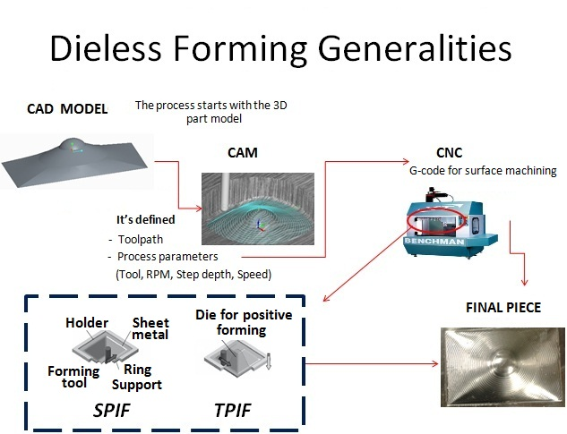

Fig. 1. CAD design of model geometry and generalities of the process [2]

The surface quality obtained from the part is affected by the step size described above and depends on the tool radius, step size and the tilt angle, as well as lubrication system and the forming speed [3]. The tool speed rotation (RPM) also has an important role as this depends on the forming quality and the temperature generated by the friction between the tool and the plate.

The incremental forming can be performed on any universal milling machine, this is a machine tool whose function is to create parts in certain ways, through a process of machining the same, with the use of a rotary tool called ball mill tool. This machine should have a system with a minimum of 3 motion axis, in numerical control computerized (CNC). Therefore, the basic elements of forming processes are incremental: the material to be formed, a ring clamping support of the workpiece, forming tool and universal milling machine CNC [4].

The incremental sheet forming through a single point of contact (SPIF), is suffering from manufacturing defects that deserve to be investigated [5] These defects are excessive thinning of the material in different areas of a geometry that lead to cracking of the piece, and lower degree of conformability of the same by increase of the acrimony of the material. Such defects could be controlled by the intensive work through different tests on parts to be deformed by this forming technique and analysis of the manufacturing process parameters, such as those raised in previous paragraphs. The creation of prototypes for sheet metal parts using a single complex-forming point incremental (SPIF), requires the generation of trajectories of optimal tools and / or sequences of tool path , to ensure that the part is formed within the specifications of the geometric design [6]. Such an assertion is fully valid for the deformation process with two points of contact, and causes the type of tool path is one of the important parameters of the process to be taken into account in this work.

This work reflects the principle of a great journey of research in new technologies for the production of sheet metal manufacturing industries with the best technology on a global level, by being nourished by the concepts of CAD-CAM/CNC. We present a result of research on the basis of experimental work with aluminum plates in this innovative process in sheet metal manufacturing , through the development of a pilot case in a special geometry, analyzing the applicability of the process in the industry and the dimensional properties of the geometry obtained, its metrology, the relationship between the thickness obtained and the geometry angles of formability, in order to check and enforce the sine law for this process, through the quantification of the variation in percentages of the reduction in thickness, and also the variation in percentage between the real thickness and the thickness measured to obtain according to equation 1 of the already well-known sine law for the embossing plate. As this law is known and applied to the spinning process - in the process of embossing with reduction of thickness is formed the product on the mandrel by means of a deformation process in which reducing the outside diameter remains constant and the wall thickness is reduced; this law announces a relationship between the formability angle and the thickness of plate (see figure 2), for a simple conical shape, the thickness of the resulting reduced wall can be easily determined through the relationship of the sine law of , and figure 2 illustrates the above, for the process of embossing sheet metal.
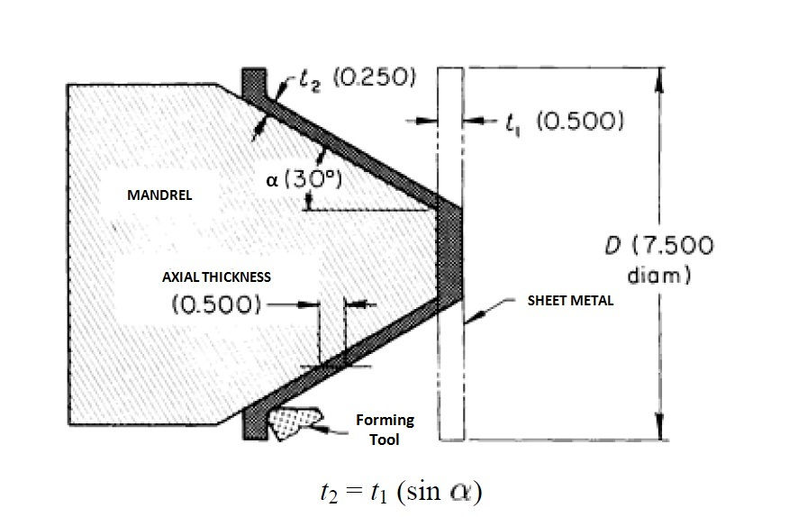
Fig. 2. Illustration of the relationship between the formability angle and sheet metal thickness through the sine law for the spinning process [10]

The incremental sheet forming without matrix is relatively new, very susceptible to research and development, in order to consolidate its position as a great option among the alternative processes of sheet metal deformation. Various authors have argued and validated the process applicability, it is very important, therefore, the research and development of new technologies and innovative processes. This is particularly true for small batch and production of prototypes. The incremental sheet metal forming can be considered as one of the promising developments for these purposes [7-8].

2.- MATERIALS AND METHODS

From a modeling in particular of a conical geometry with certain pending tilt and completed in spherical tip (see Fig.1), it is necessary to generate the best CAM strategy that define the tool path, so that the incremental forming respond to the correct plastic deformation and ensure the formation of the material, without thinning pronounced that can generate cracks or affect the dimensional quality of the product and mechanical. The material of the sheet metal work, is an aluminum alloy 1100 series (aluminum content to 99% purity, with excellent resistance to corrosion, good properties , formability, and widely used in work on metal sheets that for various uses and applications), 1.2 mm in thickness. The tool is formed of steel cemented type ball mill with 10 mm in diameter. The tool path, a very important parameter of this process, you must accommodate the particular principle of the incremental forming in two points of contact (TPIF), in which the movement or trajectory is from the inside out and upside down, synchronously in difference to the above, for the SPIF method, the movement is from outside to inside and up and down, does not have a mold or hall, by which the formability of the plate is better for the method TPIF and becomes the best alternative to test the hypothesis of the applicability of the sine law, which relates the thickness and the formability angles of the workpiece, , under the technical TPIF, have been obtained best results in terms of the geometric piece accuracy, and absence of bottlenecks or discontinuity in the same, due to a lesser degree of elastic recovery after shaping generated by the tool [ 9].

The method of incremental conformation in two points, makes reference to the points of contact between the tool and the top of the plate, and the entire mold or die (for the case in particular) and the anterior part (below the aluminum plate ). The entire mold is a piece of wood medium-density fiberboard (MDF), in the mechanized Benchmann CNC machine, this mold and the device to the method of incremental forming in two points is shown in figure 3. The machine used for the development of this experimentation is a CNC mill MB20, which has a longitudinal table with T-slots, for the mounting of fixing systems. These systems provide absolute rigidity to manufacture under the technique of incremental sheet forming on two points.

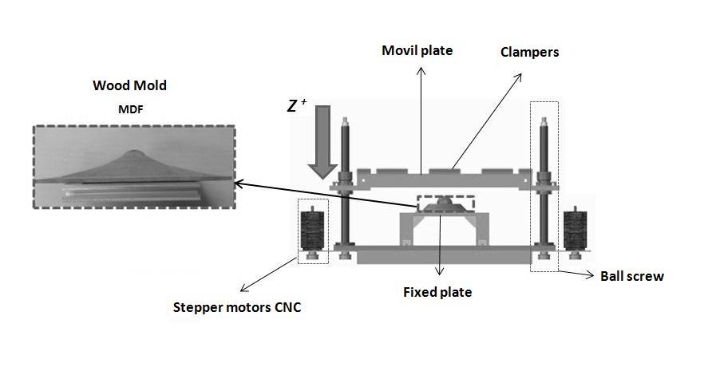
Fig. 3. Wood mold and device used for incremental forming in two points

The device is anchored to the CNC milling machine MB20 through retaining brackets with nuts type T for easy insertion into the slots in the longitudinal table. This device shown in figure 3, is an independent control that commands a z-axis of movement (vertical axis on which the plate will be pushed toward the mold or forming die), the step motors (electromechanical devices that convert a series of electrical impulses in discrete angular displacement) control the movement of the ball screws that manage the movement along the vertical axis (z axis), these screws allow the longitudinal movement of the moving platen where it is contained the sheet against the mold or forming die. There should be a synchrony between this vertical movement of the z-axis which contains the moving platen, where is clamped the aluminum plate, and the vertical displacement of the milling tool contained in the vertical axis of the milling machine. The synchronization of the movement in the z axis of the device and the milling tool machine, is achieved through the program or code G of the geometry worked, this program loads in both the machine CNC mill MB 20, as in the driver software that is connected to the device for incremental forming in two points, that way there will be a synchronous movement in the vertical axis of the device and the trimming machine commanded by a program of the same geometry to work.

The tool path has been programed using consecutive increases in the z axis (Δ z). To prevent the entry of the tool in the same place and the emergence of brands in this area has been used a strategy of spiral type (see figure 4).
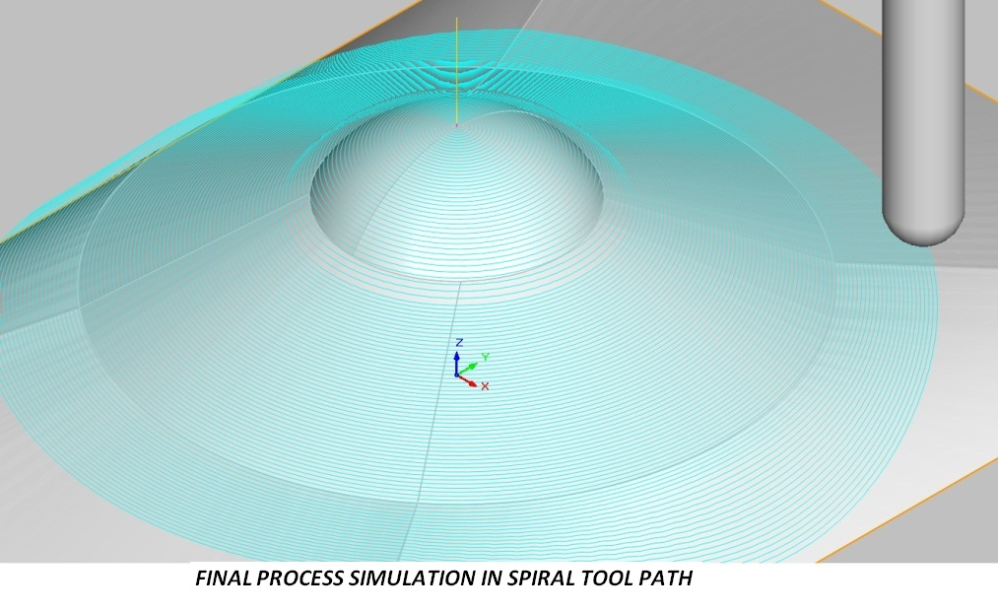

Fig. 4. Trajectory simulation tool in spiral, simulated by CNC software for conical geometry in spherical tip is complete.

Formed the piece, is the extent of the thicknesses depending on the formability angles, in different areas of the part, which is shown in figure 5. The piece is divided into three areas characterized by different formability angles, (ϕ1, ϕ2, ϕ3). These angles marked the beginning of a work of exploration of the technical TPIF in geometries and applicability in future parts close to industrial uses.

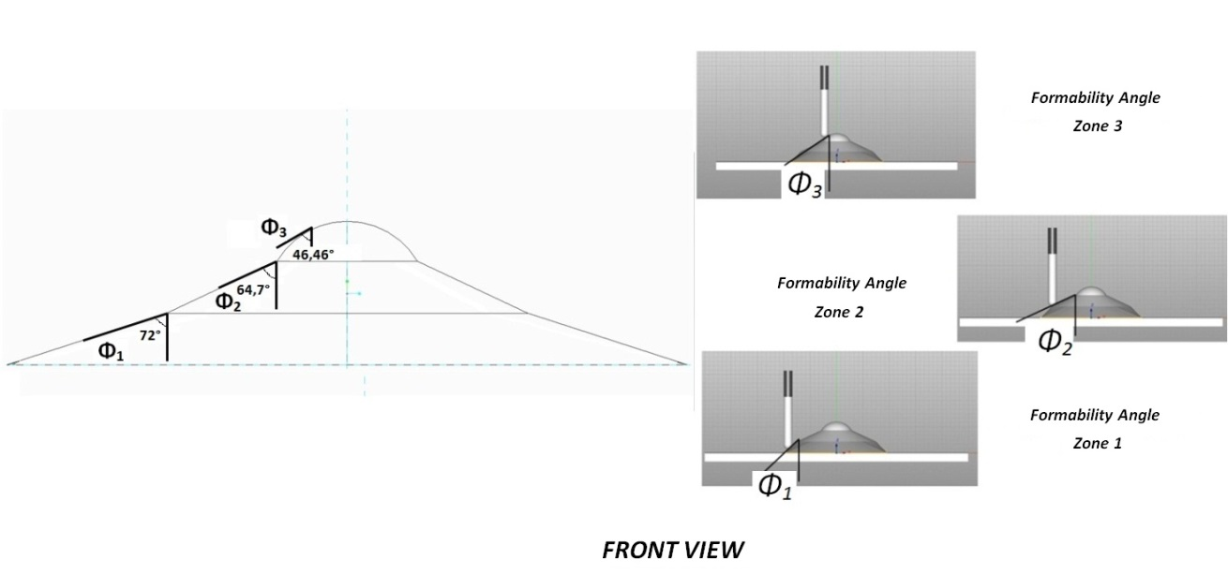

Fig. 5. Formability angles, for different zones

Based on these , formability, angles, is measured the thickness once obtained the piece, in order to determine the relationship between the angle and the thickness, on the basis of the sine law in embossing of parts, similar to the sheet metal forming process. In the equation 1 shows the sine law that relates the angle and thickness.

$Ti=TxSin (∅i)$ (1)

Equation 1. Sine Law for embossing plate [ 10]

You will get different measurements in different areas and to determine the relationship, the percentages of reduction and the applicability of the sine law for the process of incremental sheet forming in two points.

The table of initial parameters and fundamental to the technique of incremental sheet forming in two points, for the bullfight of the process in the CNC processing center, are presented in table I.

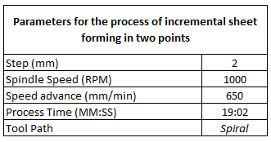

Table I. Parameters for the process of incremental sheet forming in two points

With the piece developed, it is appropriate to your analysis of visual appearance, dimensional quality, thicknesses depending on the angles, formability, and compliance with the sine law.

For the measurement of the thicknesses are victim needed emergency removal the piece in half, with the goal of locating duly the measuring instrument and ensure the criteria of a good metrological practice. For the measurements of the thickness in different areas of the part, is taking several measures in each of them with micrometers of specialized external, previously calibrated. For the case in particular is used one with field measured between 0 and 25 mm, with scale division 0.01 mm, the uncertainty is + 0.01 mm which determines the allowable tolerance or range in which the measures taken are contained, doing three measurements per zone and gives an account of the data medium thickness obtained for each.

3. - RESULTS

The obtained part through incremental forming process in the two points (TPIF) gives a good visual appearance, there are some traces of machining as a product of a 2 mm pitch, which may be more small and fine, figure 6 shows the obtained part at the end of the process.

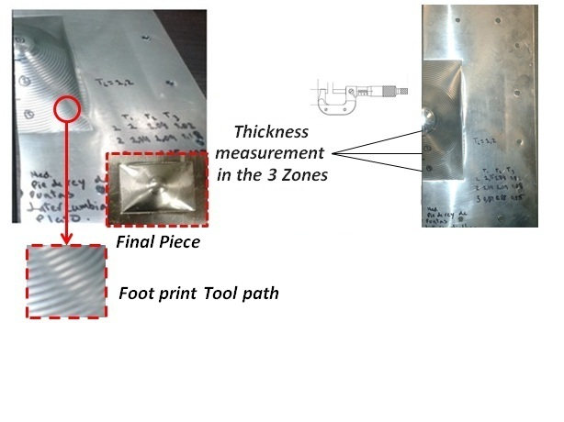

Fig. 6. Final part obtained through incremental sheet forming process in two points, footprint tool path and thickness measurement

A finer finish will depend on a lower step, it has been shown in different work carried out in the light of this technique that a minor step finishing is finer [3-4], but times and production cycles are higher. This happens because as the step is smaller, the ΔZ (increase in the z-axis) is less, which makes the difference in the increase, between foreground and background between level curves, is minimal, resulting in a more detailed figure and polished.

Following the sequence in figure 6, we measured the thickness of the part in different areas of the geometry of the same, these areas are bounded by an each formability angle, defines it (see figure 5). The results obtained according to three measurements that were performed by each zone (Ti) are presented in table II. The initial thickness of the workpiece is 1.2 mm.

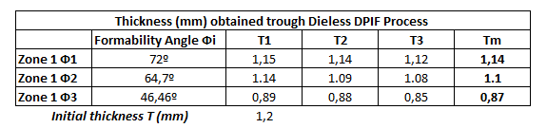

Table II. Thicknesses obtained in different areas of the part

As can be seen from table II, there are significant reductions in thickness in different areas, this is due to the narrowing generated in the plate, as a product of the pressures exerted by the tool and plastic micro deformations. The reduction in thickness can be predicted by the behavior of the same depending on the different formability angles , contained in the geometry of the workpiece through the sine law. In this work is subject to discussion the results obtained, which able to argue or refute this law in accordance with the actual data obtained and compared with the ideal. In table III, you can observe the ratio obtained between the sine law and the true thickness obtained in the piece, the variations and reduction rates obtained.

According to equation 1, the values will be displayed in function of the thickness of the angle for the process, formability, TPIF and the sine law . The deformation of sheet metal is such that is governed by the sine law , which provides that the wall thickness of the plate, after deformation, depends on the angle of training.

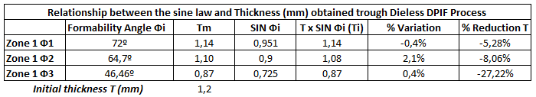

Table III. Relationship between the angle and thickness, formability, obtained through the sine law.

The variations obtained are minimal (between 0.4 % and 2.1 % ), which strengthens the thesis of the applicability of the sine law in this process similar to the sheet embossing , there are only significant reductions in thickness and are detailed below, in the light of the consulted literature [10]. There is a significant reduction of thickness in the zone 3, corresponding to 27.22 % when it is at an angle of 46.46 ° , there is also a minimum reduction in zone 1 and 2 corresponding to 5.28 % and 8.06 %, respectively, to wider formability angle, the reduction in thickness is less, therefore it is recommended that work with geometries with angles not very righteous nor aimed at 0° , already that rupture can occur and/or cracking of the material by effect of the pressure of the tool and greater contact area between this and the workpiece.

4.- DISCUSSION

By way of discussion, and on the basis of the results obtained in this work with regard to thickness, depending on the formability angle, some authors confirm and enunciated the sine law for processes of embossing plate [2], but do not show concrete experimentation to technique with a geometry in particular and under the method that is studied in this work. Other authors studied, have not been able to predict and/or estimating the final thickness of the part on the basis of the application of the sine law in its components by experienced technical , also some authors have argued and experienced in their work that the final thickness of the part can be estimated using the sine law , which suggests that in parts with vertical walls , the thickness would tend to be zero, for the SPIF process, and, to achieve these geometries, is required to make multiple passes [11]. In this work confirms the same, but for the other technique derived from this process, the technical TPIF, with very interesting results and that could suggest performing geometries with vertical walls in a single pass or few strokes. The foregoing suggests a principle of research as opposed to the arguments of the results obtained in terms of applicability of the sine law, which was achieved in this work, but still capable of discussion in the scientific environment for this innovative technique.

The sine law has been widely addressed, enunciated, experienced in processes of embossing sheet metal , but, for the particular technique (incremental sheet forming in two points), has been little studied and the results obtained in this work are beginning to mark a pattern of research and starting point or reference, to strengthen the thesis of their applicability to the process addressed in this work.

5.- CONCLUSIONS

The process of incremental sheet forming that is due to the technique of deformation by forming two points is very applicable as technical CNC forming, develops conical geometries with certain degrees of slope or grade and the relationship formability angle, - thickness is obedient to the sine law , the formability mechanical obtained of the piece is acceptable. It deserves a good research and development that support the results obtained in this and many work already done and what satisfies as a highly competitive process in prototyping of complex parts and lots or low production runs, as excellent low-cost alternative in tooling, good surface quality and dimensional.

You can also conclude that for this particular process (incremental sheet forming in two points) the sine law applies to the experimental geometry worked and that it is possible to predict the behavior of the material thickness as a function of formability angle , such is the case submitted that deals with this work.

To obtain significant reductions of thicknesses with angles and vertical walls, according to the analysis of the sine law , the incremental forming process required for the formation of these geometries, make several passes, even with the existence of a complete mold of support (TPIF method, with two contact points), but with better properties forming and fewest number of passes, with respect to the method SPIF, because there are two points of contact which guarantee a best workpiece formability.

It deserves a particular analysis strategy and tool path, have already been done research and work on how to optimize this parameter under the technical TPIF [12] [13], this together with the analysis of other variables influence the incremental forming process, would provide major results in the field of research and development of the process of incremental sheet forming .

ACKNOWLEDGMENTS

The authors would like to thank the entire staff of the laboratory of machines and tools of the EAFIT University, as well as the laboratory of metrology, as the teams work and measurement were essential to the research results obtained in this work. Also the group of research production technologies, by the support and academic support in the realization of this research work.

TO LEARN MORE

[ 1] Matsubara S. "incremental back-ward bulge forming of sheet metal with a hemispherical tool". Journal of the JSTP. 1994 .Vol. 35 P. 1311-1316.
[ 2] Jeswiet J, Micari F, Hirth-tooth Form G et al. "Asymmetric single point incremental forming of sheet metal". CIRP Annals-Manufacturing Technology. August 2005.Vol.54-2. p. 623-649. ISSN: 0007-8506
[ 3] Paramo G, Benitez A. "deformation of foil without incremental matrix (dieless) as a viable alternative to forming processes of conventional plate". Inge CUC Magazine. June 2013, Vol. 9-1. p. 115-128. ISSN 0122-6517.E-ISSN 2382-4700
[ 4] Garcia - Alejandro. "Analysis and characterization of Single Point method incremental forming in the technology of numerical control for a case study". Director: Gabriel Moor. [Thesis]. EAFIT University Medellin, School of Engineering, 2011.
[ 5] Hussain G, Ghamdi, Khalatbari H et al. "Forming parameters and forming defects in incremental forming process: Part B". Materials and manufacturing processes. April of 2014. Vol. 29-4. p. 454-460. DOI: http://dx.doi.org/10.1080/10426914.2014.880457
[ 6] Behera , Lauwers B, Duflou J et al. "Tool path generation framework for accurate manufacture of complex 3D sheet metal parts using single point incremental forming". Computers in industry. May 2014 Vol.65-4. p. 563-584. DOI: http://dx.doi.org/10.1016/j.compind.2014.01.002
[ 7] Tisza M. "General Overview of incremental sheet forming". Journal of achievements in materials and manufacturing engineering. November of 2012. Vol. 55-1.p. 113-120. ISSN: 1734-8412
[ 8] Tisza M, Kovacs P, Lukacs Z. "Incremental forming: An innovative process for small batch production". Materials science forum. 2013. vol.729-1.p. 85 -90. DOI: 10.4028 /www.scientific.net/MSF.729.85
[ 9] Silva M, Martins P. "Two-point incremental forming with partial die: Theory and experimentation". Journal of materials engineering and performance. April of 2013. Vol. 22-4. p. 1018-1027. DOI: http://dx.doi.org/10.1007/s11665-012-0400-3
[ 10] Metals Handbook, Vol. 14. Forming and forging, 9th ed. , ASM Int., 1988
[ 11] Tanaka S, Hayakawa K, Nakamura T. "incremental sheet forming with direction control of path plans". In: 10 th International Conference on technology of competition-plasticity /Opacità, (Aachen, Germany September 25 2011), [ S. I], 2011. p. 503-507. ISBN 978-351400784-0
[ 12] In CellinoAttanasio , Ceretti E, Giardinni C et al. "Asymmetric two points incremental forming: Improving surface quality and geometric accuracy by tool path optimization". Journal of materials processing technology. February 2008 - Vol.197-1-3. p. 59-67. DOI: http://dx.doi.org/10.1016/j.jmatprotec.2007.05.053
[ 13] Fiorentino , Ceretti E, in CELLINO ATTANASIO TO et al. "Analysis of forces, accuracy and formability in positive incremental sheet forming die". International Journal of material forming. August of 2009. Vol. 2-1. p. 805-808. DOI: http://dx.doi.org/10.1007/s12289-009-0467-z

