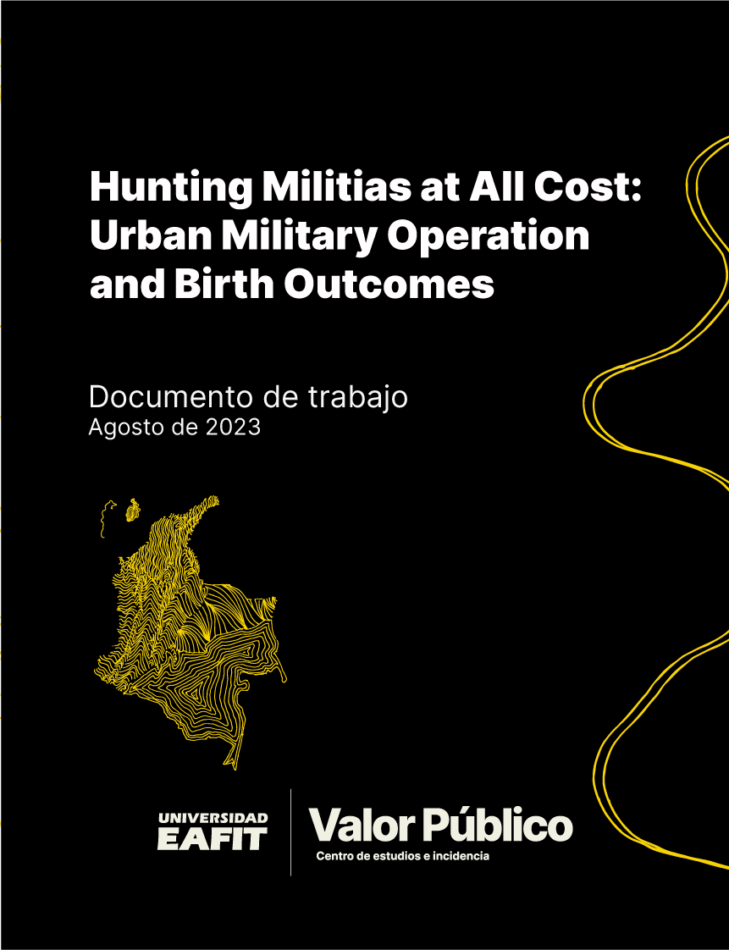

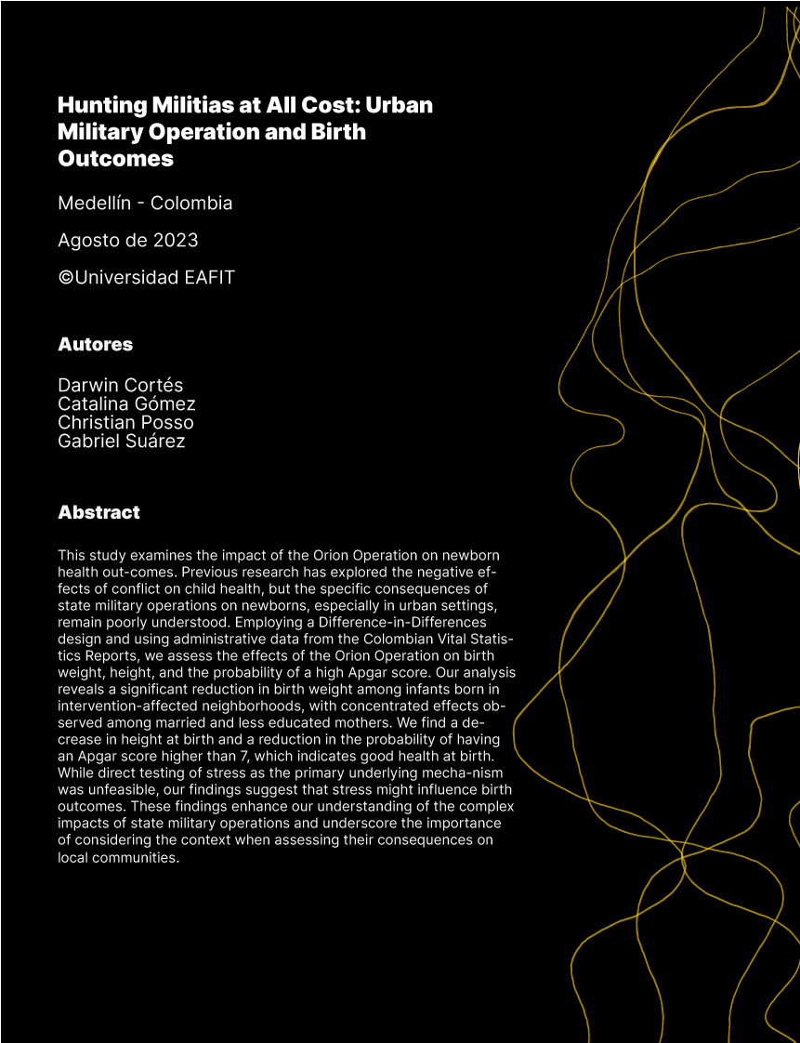

Hunting Militias at All Cost: Urban Military Operation

and Birth Outcomes
Darwin Cort´es Catalina G´omez Christian Posso Gabriel Su´arez August 2023

Abstract
This study examines the impact of the Orion Operation on newborn health out- comes. Previous research has explored the negative effects of conflict on child health, but the specific consequences of state military operations on newborns, especially in urban settings, remain poorly understood. Employing a Difference-in-Differences de- sign and using administrative data from the Colombian Vital Statistics Reports, we assess the effects of the Orion Operation on birth weight, height, and the probability of a high Apgar score. Our analysis reveals a significant reduction in birth weight among infants born in intervention-affected neighborhoods, with concentrated effects observed among married and less educated mothers. We find a decrease in height at birth and a reduction in the probability of having an Apgar score higher than 7, which indicates good health at birth. While direct testing of stress as the primary underlying mecha- nism was unfeasible, our findings suggest that stress might influence birth outcomes. These findings enhance our understanding of the complex impacts of state military operations and underscore the importance of considering the context when assessing their consequences on local communities.
Keywords Birth Outcomes; Conflict; Colombia; Urban Military Operation
JEL Codes D74, I12, J13
∗We are grateful to Arlen Guarin, Mounu Prem, Paul Rodriguez, Michael Weintraub, Gustavo Garc´ıa, Andr´es Moya, Santiago Saavedra, Stanislao Maldonado, Jorge Gallegos, Sebasti´an Ram´ırez, Esteban Alem´an- Correa, Andr´es Gallegos-Vargas and Eduard Martinez for helpful comments and suggestions, and participants of the RATA Workshop and Brown Bag seminar at Universidad del Rosario and Brown Bag and FEG semi- nars in EAFIT. Mariana Lopera and Pablo Uribe provided excellent research assistance. Darwin Cortes also acknowledges financial support from Fulbright-Colciencias and Colombia Cient´ıfica - Alianza EFI no 60185 contract n. FP44842- 220-2018, funded by The World Bank through the Scientific Ecosystems, managed by the Colombian Ministry of Science, Technology, and Innovation (MINCIENCIAS). The opinions expressed herein belong to the authors and do not necessarily reflect the views of Banco de la Repu´blica or its Board of Directors.
†Corresponding author. Universidad del Rosario. E-mail: darwin.cortes@urosario.edu.co.
‡Universidad Eafit. E-mail: cgomezt1@eafit.edu.co.
§Banco de la Repu´blica. E-mail: cpossosu@banrep.gov.co.
¶World Bank. E-mail: gabrielj585@gmail.com.

Introduction
In recent years, extensive research has been conducted on the adverse impact of conflict on child health outcomes in economics (Akresh et al., 2012; Mansour and Rees, 2012; Akresh et al., 2011; Brown, 2018; Torche and Shwed, 2015; Dagnelie et al., 2018). However, relatively little attention has been given to the impact of State military operations on newborn health outcomes in urban areas. This paper address this research gap by examining the effects of the Orion Operation, the largest urban military operation in Colombia’s history, on birth weight, height, and the probability of having a high Apgar score. Specifically, the study focuses on the effects of the state-led military operation on newborn health outcomes in socio-economically disadvantaged urban areas, which may have unique features and implications compared to other settings.
Colombia’s internal armed conflict significantly impacted both urban and rural areas. The conflict affected millions of individuals, with about nine million victims (16 percent of the total population). While the conflict was primarily concentrated in rural and small mu- nicipalities, it also significantly affected urban areas. One such area was Medellin, Colombia’s second-largest city, where several guerrilla groups established a strong presence, particularly in the impoverished Comuna 13 (also known as Comuna San Javier ). To regain control of the area, the government launched Operation Orion in October 2002 under the newly elected presidency of Alvaro Uribe. This operation involved approximately 1,500 police and army personnel with sophisticated weapons, helicopters, tanks, and other military vehicles. While the government considered the operation a success, little is known about its unintended consequences for newborns in the affected areas.
In our study of the Orion Operation’s impact on newborn health outcomes, we depart from prior research in several ways. First, rather than examining the adverse effects of non-state armed actors, as in previous studies (Brown 2020; Sherrieb and Norris 2013; Kop- pensteiner and Manacorda 2016; Mansour and Rees 2012; Quintana-Domeque and R´odenas- Serrano 2017; Camacho 2008), our paper focuses on the impact of a state military operation. Second, while much of the literature on internal conflict has focused on rural areas (Akresh et al., 2012; Bundervoet et al., 2009; Akresh et al., 2011), we specifically focus on econom- ically disadvantaged urban neighborhoods. Given the high spatial concentration of urban poverty, the potential effects of conflict on these communities may be even more severe.
Finally, unlike much of the existing literature on urban environments, the Orion Opera- tion was a short-term and highly intense counterinsurgency operation that involved tactics and weapons more typical of open-field army confrontations1. Notably, violent events asso- ciated with the Orion Operation were officially labeled as interventions to end the conflict and improve conditions in the targeted neighborhood. This study highlights the need to con- sider the context of urban conflict and the importance of understanding the state military operations’ complex and multifaceted impacts on local communities.
1Many authors, such as Poveda and Martínez 2023, Kreif et al. 2022, Arias 2021, Conzo and Salustri 2019, Hameed et al. 2023, and Grossman et al. 2019, have studied long-term conflicts. However, there is also literature concerning short-term operations or attacks, such as the World Trade Center Disaster (Brown 2020 and Spratlen et al. 2022) and the Catalonia attacks in Spain (Armijos Bravo and Vall Castell´o, 2021).

Our study employs a difference-in-differences design (DiD) and administrative data from the Colombian Vital Statistics Reports (VSR) to investigate the impact of the Orion Opera- tion on birth outcomes. We aim to identify the Orion Operation’s causal effect by leveraging the operation’s timing and differential exposure among neighborhoods in Comuna 13 and the rest of Medellin (243 neighborhoods). Specifically, we focus on newborns conceived between July and October 2002, during the first trimester of pregnancy, when they were potentially affected by the Orion Operation. To account for confounding factors, we estimate a standard DiD design and use the Doubly Robust estimators (DR) for DiD research designs proposed by Sant’Anna and Zhao (2020). This approach allows us to incorporate covariates without imposing additional assumptions and combines a regression approach with a re-weighting procedure.
Our analysis reveals significant associations between exposure to the Orion Operation during the first trimester of pregnancy and adverse birth outcomes. We find a statistically significant reduction in birth weight by 125 grams (g) (relative to the average of 3067 g), a decrease in height by 0.67 centimeters (cm) (relative to the average of 49 cm), and a decrease in the probability of having an Apgar score higher than seven by four percentage points (pp) (relative to an average of 92 percent). As most mothers in the affected neighborhoods were likely to have been exposed to the intervention, our estimates already account for the potential scale-up of its impact, providing insights into the effects of actual exposure to the Orion Operation.
To ensure the robustness of our findings, we conducted a series of sensitivity analyses. We estimate the treatment effects using standard DiD and two-way fixed effects models, and the Sant’Anna and Zhao (2020) DR method. Across all estimation strategies, our results remain consistent. We examine potential heterogeneous treatment effects across the distribution of newborn health outcomes. In particular, we test whether the Orion Operation affected mostly births at the bottom of the distribution (e.g., low birth weight) or if, on the contrary, the results are concentrated in the median part of the distribution. To do that, we use the Unconditional Quantile Regression (UQR) approach developed by Firpo et al. (2009). Our analysis indicates that the treatment effects are concentrated around the median birth weight and height, with no substantial effects observed at the lower tail of the distribution. To assess the internal validity of our identification strategy, we implement several tests.
First, we adopt a neighborhood-month panel approach to mitigate concerns regarding po- tential biases related to changes in the number of newborns, such as intra-urban migration or fetal mortality, which could affect the composition of treated women. This approach aggregates all the birth registrations in the Colombian VSR by neighborhood and month. Importantly, our analysis reveals that the number of births per neighborhood remained unaf- fected by the Orion operation, providing evidence that changes in the composition of treated women did not bias our estimates. Second, we employ falsification tests to assess the valid- ity of our findings. Specifically, we simulate a scenario in which the intervention occurred one year before the actual date, and the results demonstrate insignificance, supporting the robustness of our estimates. Third, we conduct a permutation test by randomly assigning the treatment to different neighborhoods 10,000 times. The outcomes of this analysis cannot

provide sufficient evidence to reject the null hypothesis that random exposure to the state military operation has no impact on birth outcomes. Finally, we ensure the robustness of our inference through the application of the wild bootstrap approach proposed by MacKinnon and Webb (2019), and the randomization inference method developed by MacKinnon and Webb (2020) and implemented by Roodman et al. (2019). Our analysis confirms the stabil- ity of our findings when subjected to these additional procedures, further strengthening the validity of our results.
Several mechanisms may explain the relationship between the Orion Operation and ad- verse birth outcomes. On the one hand, the operation imposed a forced lockdown on resi- dents, which may have affected nutrition and access to health services, leading to negative birth outcomes because of inadequate food and a lack of medical guidance and supervision (Abu-Saad and Fraser 2010, Alexander and Korenbrot 1995). The VSR data provides in- formation on the number of prenatal appointments and gestational age, which we use in our study to examine the detrimental consequences of restricted access to healthcare and inadequate nutrition. Initially, we investigate whether the military intervention significantly impacts the number of prenatal visits or the likelihood of having an adequate number of visits according to the World Health Organization (WHO) guidelines, which recommend at least four visits during pregnancy at that time.2 These measures serve as proxies for access to prenatal medical care. Similarly, we define Small for Gestational Age (SGA) as birth weight below the 10th percentile for gestational age, a widely used indicator of fetal growth restriction because of insufficient nutrients and oxygen during pregnancy (Slyker et al., 2014; Villar et al., 2014). SGA has been associated with adverse health outcomes in the short and long term (Kramer, 1987; Kc et al., 2016). Our analysis reveals that the Orion Operation has no significant effect on these indicators.
On the other hand, the operation may have heightened stress levels in pregnant women, which could adversely affect fetal health and development. Existing studies suggest that maternal stress during pregnancy is linked to reduced fetal growth and lower birth weight (Wadhwa et al., 1993), elevated levels of stress hormones in the fetus (Glynn et al., 2001), cognitive and behavioral problems, increased risk of obesity and metabolic disorders, as well as impaired immune function in the offspring (Entringer et al., 2012). Furthermore, maternal stress during pregnancy is associated with a higher likelihood of premature birth, low birth weight, and infant mortality (Davis et al., 2007).
Although the VSR data does not directly measure maternal stress or other health in- dicators for mothers, we have reasonable grounds to believe that maternal stress may have played a role in our specific context. First, the literature in development economics offers evi- dence supporting the notion that maternal stress serves as a primary pathway through which conflict events may impact maternal and fetal health (Spratlen et al., 2022). Furthermore, anecdotal evidence and testimonies support the intense psychological pressure inflicted on the residents of Comuna 13 during the Orion Operation (Aricapa 2017; Memoria Hist´orica

2See https://www.who.int/news/item/07-11-2016-pregnant-women-must-be-able-to-access-the
-right-care-at-the-right-time-says-who.

2011).3 Last, we observe that the effects on birth weight and height are primarily concen- trated among married women or those in consensual unions, which may be explained by the heightened stress experienced by women with a partner during violent events that endanger their partner’s life—an occurrence frequently observed in the Colombian conflict.4
Our research contributes significantly to the existing literature in several ways. First, unlike previous studies that focused on the effects of terrorism and non-state military oper- ations (Brown, 2020; Mansour and Rees, 2012; Camacho, 2008; Koppensteiner and Mana- corda, 2016), we provide new evidence on the effects of state-led military operations in urban environments. This novel approach expands our understanding of the impacts of military interventions. Second, our study extends the analysis of the effects of the Colombian internal armed conflict (Angrist and Kugler, 2008; Camacho, 2008; Camacho and Rodriguez, 2013; Dube and Vargas, 2013; Vargas, 2012) on early life shocks, encompassing a scale and scope that has not been explored before. Specifically, our paper delves into the impact of the Colombian conflict on infants’ health outcomes (Camacho, 2008; Duque, 2017; Kreif et al., 2022; Rodr´ıguez, 2022), thus providing the first empirical evidence of the influence of state military operations in impoverished urban areas.
The remainder of this paper is organized as follows. Section 2 provides institutional con- text, situating Operation Orion within the broader context of military intervention in urban settings. Section 3 describes the data sources and provides descriptive statistics, summariz- ing the key features of the data and highlighting any relevant limitations. Section 4 describes the identification strategy, outlining the key assumptions underlying the analysis and dis- cussing the potential for bias. Section 5 presents the main findings, providing estimates of the effect of Operation Orion on birth outcomes. Section 6 concludes.

Institutional Context

Colombian Internal Conflict
Colombia was one of the countries most affected by violence during the second half of the 20th century. The internal conflict started in the mid-1960s with the foundation of the left- wing guerrilla groups Revolutionary Armed Forces of Colombia (FARC, its Spanish acronym) and the National Liberation Army (ELN, its Spanish acronym), which were located mainly in rural areas and came to control an important part of the country’s territory. Indeed, as
3The primary objective of the operation was to gain control of Comuna 13, an area previously under the control of guerrilla groups. Unfortunately, the operation was characterized by violence and intimidation towards residents. It commenced with a power outage that caused panic among the residents, followed by the arrival of two helicopters that demolished the roofs of several houses. This was succeeded by an exchange of gunfire between official forces and militiamen, accompanied by the entry of armored tanks in the early morning. The residents of Comuna 13 found themselves trapped between the official forces and paramilitaries in the upper neighborhoods, resulting in a death toll of 100 individuals, 300 injuries, and an estimated 500 missing persons (Memoria Hist´orica, 2011).
4The disproportionate impact of violent conflict in Colombia on men is evident from the fact that 92
percent of conflict-related deaths occur among males (CNMH, 2023).

a military strategy, the guerrillas sought to populate areas with a markable absence of the state, thus achieving the control of a consolidated location that increases their ability to expand and extract rents through crime (Aricapa, 2017). As a result, the internal conflict that lasted over fifty years has left more than a million homicides and around 8.4 million displaced.5
Although the conflict initially mainly concentrated in rural areas, some guerrillas started locating small cells in the main cities. That was the case of Medellin. Guerrilla groups took advantage of the fact that the most violent neighborhoods were growing rapidly but with high levels of inequality, poverty, and a lack of government authority. In particular, ELN and FARC targeted the north and west of the city in Comuna 13 or San Javier, and Comuna 1 or Popular, whose neighborhoods are known to be among the poorest in the city. Thereby, in the mid-1990s, the ELN coordinated the land invasion of El Salado, a neighborhood between San Javier and the rural area of San Cristobal in the western part of the city, where they illegally offered plots of land and construction materials to displaced individuals from the pacific coast of Colombia (Memoria Hist´orica, 2011). Simultaneously, several independent militias also exercised control over the people and territory, assigning land plots and distributing food and goods from the assault of transporting vehicles. In addition, the FARC militias were also present towards the end of the 1990s, consolidating Comuna 13 as one of the areas with the highest risk and difficulty to control for the local and national governments.
The conflict escalated in 1997 when several militias of the right-wing paramilitary group6
Autodefensas Unidas de Colombia (AUC) tried establishing territorial control in Comuna 13. By 2002, the situation worsened because the left-wing militias prohibited neighbors outside Comuna 13 from entering, held checkpoints on buses, and paralyzed schools. Consequently, public transport in several areas of Comuna 13 was interrupted, and some local businesses closed.
To counteract the situation, the AUC engaged in violent confrontations through a series of military interventions across different neighborhoods of Comuna 13. The most critical moment occurred on May 31, when the mayor of Medellin, Luis P´erez Gutierrez, inaugurated the new bus terminal in San Javier. The FARC attacked the bus that transported the mayor, and although he was not hurt, this attack triggered several measures to regain control of the area. First, the Police started constructing a new military base in Comuna 13, reinforcing the force with 300 police officers equipped with specialized equipment and weapons and a 500 million Colombian Pesos fund to pay informants (Aricapa, 2017). Second, in August 2002, after possessing Alvaro Uribe as the new President, the mayor Luis P´erez requested intervention from the national government. Finally, in October 2002, the military and police authorities planned a decisive move: Operation Orion.
5Statistics retrieved from Registro U´nico de V´ıctimas, https://www.unidadvictimas.gov.co/es/
registro-unico-de-victimas-ruv/37394, accessed April 15, 2023.
6According to the Cambridge Academic Content Dictionary, ”a paramilitary group is organized like an army but is not official and often not legal”, https://dictionary.cambridge.org/us/dictionary/ english/paramilitary, accessed August 17, 2023.

Operation Orion
Operation Orion was the largest and most dramatic urban military operation at Colombia’s urban level (Aricapa, 2017). As Montoya (2021) described, at midnight on October 16, 2002, 1,500 men from the army and police were mobilized. They arrived in military vehicles at the edge of the Comuna 13, armed with sophisticated weapons. According to the declarations of several paramilitary leaders, the operation was accompanied by paramilitary members who had previously carried out intelligence work (Memoria Hist´orica, 2011).
From then on, the men from the Special Counterterrorism Command started walking up into the target area, starting with the neighborhood of San Javier. The objective was to take control of this geographical area of the city controlled by the militiamen, mainly members of the left-wing guerrilla group ELN. Unfortunately, the foray into the neighborhood was violent and generated fear among the inhabitants. From the start of the operation, the electric power was cut off. Then, two helicopters entered, lifting the roofs of some houses, and the exchange of high-caliber firearms (even those used for war in rural areas) began between the official forces and the militiamen.
In the early morning, the war tanks entered, continuing the shooting and the back and forth of grenades. This was how both the inhabitants of the Comuna 13 and the militiamen (some of them recruited teenagers) were trapped between the official forces coming up and the paramilitaries in the upper neighborhoods. The dead were accumulating, and some bodies were never found. According to interviews and testimonies, the Orion Operation inflicted intense psychological pressure on the inhabitants who lived in the affected areas (Aricapa, 2017). Memoria Hist´orica (2011) said that Operation Orion remained in the memory of the inhabitants of Comuna 13 as the day when the war entered “the bowels of their homes.”
In the Operation, the “informants” were vital. They were protected by military vehicles, although they wore bulletproof vests like the official forces. These people would be safe until the authorities took over the territory. Most of these informants were militiamen in the past. However, the payment offered by the right-wing paramilitary groups was higher than what they were receiving, and they changed sides (Montoya, 2021).
The Informants were accompanied by officials from the Prosecutor’s Office, who, with a list of names of militiamen and collaborators, went from house to house looking for these peo- ple. The public force was responsible for entering the interior of the designated houses and exhaustively searching for subversives, hostages, arms, contraband, and illicit substances, which implied high stress for the inhabitants of the houses. The residents of these neigh- borhoods protected themselves from stray bullets, explosions, or violence upon entry of the home inspection, under beds, and by putting mattresses, cardboard, or other materials on windows, doors, and walls (Montoya, 2021).
The official authorities’ truth, according to Montoya (2021), is not entirely accurate in the sense that it was said that the successful Operation Orion of 2002 was carried out by the state public force (military and police), concealing that it was in turn, a result of an alliance with the paramilitaries. Outside the law, these criminal groups of right-wing polit- ical orientation committed multiple human rights violations and exercised disappearances, extrajudicial executions, and forced population displacement. According to several authors,

the operation was not a victory for the State but a defeat for the population of the Comuna 13, who faced the consequences of the indiscriminate violence of the official forces and the paramilitaries.
Although there is no consensus about the duration of the operation, most sources stated that it lasted around one week between October 16 and 23. We use the investigation report of Memoria Hist´orica (2011) to define the neighborhoods where Operation Orion took place. Comuna 13 had 19 neighborhoods by 2002. Six of those were intervened: Belencito, Coraz´on, 20 de Julio, El Salado, Nuevos Conquistadores, and Las Independencias.7 This information and the operation’s dates allow us to build a repeated cross-section of births in Medellin from 2002 to 2003.

Data

Birth Records
Our primary source of information is the VSR collected by Colombia’s Administrative De- partment of Statistics (DANE, for its Spanish acronym). VSR has data about the specific date and hospital where each woman gave birth and about the newborn, such as sex, weight, height, and Apgar score. It also includes some variables with information about the mothers, such as department and municipality of residence, age, educational attainment, type of health insurance, marital status, number of children, and number of pregnancies. Specifically, VSR allows us to identify the neighborhood where each mother is located.
We focused on birth certificates in Medellin from 2002 to 2003 to consider the cohort right before and potentially exposed to the intervention. The key variables for identifying the mothers affected by the operation are birth date, gestational length (weeks), and the neighborhood of residence. All birth certificates include the first two variables, which we used to build the date of conception. However, although the birth certificates for 2003 were supposed to have the neighborhood of residence, it was only reported between May and August 2003. Therefore, we can only observe the neighborhood for mothers who gave birth between October 17 and December 31, 2002, and between May and August 2003, periods that match newborns affected by the operation during the third and first trimesters of pregnancy, respectively. For this reason, we cannot estimate the effect on newborns exposed during the second trimester.
We used two different samples for newborns exposed in the first and the third trimesters because previous literature evidences the importance of exposure time.8 Our principal anal- ysis focuses on mothers affected by the Orion operation in their pregnancy’s first trimester since previous evidence shows it is where the effect of violence on birth outcomes concentrates (Mansour and Rees, 2012; Camacho, 2008; Dagnelie et al., 2018; Brown, 2018; Quintana- Domeque and R´odenas-Serrano, 2017; Le and Nguyen, 2020). Nonetheless, in the appendix,
7See Figure A1 where these neighborhoods are presented in dark gray, the rest of the Comuna 13 are in light gray, and the rest of the districts of Medellin are in white.
8See, e.g., Camacho (2008); Mansour and Rees (2012); Koppensteiner and Manacorda (2016) and others.

we also show the results using newborns exposed during the third trimester (See table A1). To provide additional evidence on the validity of our estimations, we also used VSR from 2000 to 2001 to run a placebo test with a fake intervention date, October the 16th, 2000, two years before Operation Orion. Nonetheless, gestational length is not available in weeks but in intervals, so we cannot precisely determine the mothers possibly exposed to the placebo. Still, we can approximate them using Koppensteiner and Manacorda (2016) approach, where intervals are converted into average gestational length in weeks using precise gestation in weeks available in the 2002 and 2003 birth data. Specifically, we use the minimum gestational length in each interval and the average weeks observed in 2002-2003 data. As expected, given the placebo treatment, we find similar results if we run a similar exercise
with small variations in this definition.9
VSR allows the measurement of several outcomes, including birth weight, birth height, and Apgar score. Birth weight has been one of the key health measures at birth studied in the literature (Currie, 2011). Birth weight, particularly low birth weight, is highly correlated with mortality (World Health Organization, 2016; Almond et al., 2005; Gonzalez and Gilleskie, 2017). Low birth weight is defined as being born with a birth weight below 2,500 g. Instead of focusing on a binary outcome such as low birth weight, in the results section, we estimate UQR (Firpo et al., 2009) for a wide variety of values on the birth weight distribution, including 2500 g.
Height is also a predictor of the health of individuals (Raghavan et al., 2022). Chil- dren experiencing persistent short stature exhibited diminished verbal and language scores compared with children with the typical height. Moreover, children with short stature ex- hibited language scores approximately a quarter of a standard deviation lower than those with typical height. Short stature also predicts inferior language development (Freer et al., 2022). Children with short stature consistently displayed a higher likelihood of belonging to the lowest-performing group while less inclined to be associated with the high-score group (Freer et al., 2022).
The Apgar score is another commonly used measure in literature to measure newborn health status (Almond et al. 2010 and Lin 2009). The Apgar score is based on the observable health of the newborn one minute after giving birth. Its calculation uses information on breathing, heart rate, color, reflexes, and muscle tone after one minute of giving birth (Moore et al., 2014). Initially, this measure was created to evaluate a newborn’s immediate condition and the potential need for resuscitation. Recent literature shows that the Apgar score is a good predictor of infant death and has several practical advantages (Almond et al., 2005). First, it is relatively easy to collect. Second, it is usually available in data. Finally, it is a measure that does not depend on a rare event (such as mortality). For our empirical exercises, we use an indicator variable of whether the newborn scored above or equal to 7 in Apgar, which measures good health at birth.
9We have access to all death reports, which, in principle, would allow us to estimate the effects on fetus mortality. Although the death certificate includes information on the exact date of the death, it does not provide information on the neighborhood of residence. Given this constraint, we cannot define the treatment of all potential pregnancies.

Main Sample
We identified infants potentially affected in-utero by the operation according to their birth and conception dates, which resulted in around 9,700 registries, 5400 newborns potentially affected when they were in the third trimester of pregnancy (mothers who gave birth between October 17 and December 31 of 2002), and 4,300 newborns potentially exposed during the first trimester (mothers who gave birth between May 1 and July 30 of 2003). These newborns make up the post-treatment sample. We use the same dates but for the previous years to identify the pre-treatment sample of mothers not exposed to the operation.
We present results for newborns affected in the first trimester since previous evidence has shown that the effects concentrate on that stage of pregnancy (see, for example, Mansour and Rees 2012 or Camacho 2008) and because of data limitations mentioned in previous section. The final data set has 10,760 observations (birth registries) classified into treated or control according to the area of residence reported in the hospital by their mothers.
Table 1 presents the summary statistics of the cohort born in 2002 before the operation in Medellin. As shown in the table, infants weigh, on average, 3,067 g, with a standard deviation of 461 g. Infants have an average height of 49.1 cm, with a standard deviation of 2.4 cm. 92% of the births had an Apgar score of seven or more. Concerning the socioeconomic variables, 26.5% of the deliveries are from mothers with primary or lower educational attainment, around 70% are from married mothers or mothers in a consensual union, and the average age of the mothers is 25.5 years old (standard deviation of 6.8 years). Finally, about 3 percent of the births are from mothers living in neighborhoods affected by the Orion operation.

Empirical Strategy
To identify the causal effect of Orion Operation on birth outcomes, we exploit the timing of the operation and the neighborhood variation where the intervention occurred. Specifically, we exploit the Orion operation’s timing, which started on October 16, 2002, and lasted one week, and the differential exposure to violence associated with the operation among different neighborhoods in Comuna 13 and the rest of Medellin.
We start by identifying all the births from pregnant women affected by the Orion opera- tion in their first trimester of gestation. The deliveries potentially exposed to the intervention were born between May 1, 2003, to July 30, 2003. We defined this sample as the cohort born after the operation. Second, we identify all the births born in the sample dates but one year before, i.e., those born between May 1, 2002, to July 30, 2002, not exposed to the operation. We defined this sample as the cohort before the operation. Finally, we identified the neighborhood where the mothers lived at the moment of the intervention, and we defined treated neighborhoods as those where Operation Orion took place. Control neighborhoods are all other neighborhoods in Medellin. We estimate a standard DiD regression:
Y_{int} = α₀ + α₁Orion_{n} + α₂P ost_{t} + βOrion_{n} × P ost_{t} + θX_{it} + ε_{int} (1) where Y_{int} is the outcome of child i from neighborhood n at time t, Orion_{n} shows whether

Table 1: Summary statistics - pre intervention

(1) (2)
Mean S.D.
Birth Outcomes

Apgar 1 minute 5 or 6
Birth weight | 3,067.854 | 461.345
Height | 49.092 | 2.414
Gestational length (weeks) | 36.647 | 1.595
Premature | 0.377 | 0.485
Apgar 1 minute ≥ 7 | 0.920  0.043 | 0.271  0.203

Apgar 1 minute < 5 0.014 0.118
Birth and pregnancy characteristics
Prenatal visits | 5.397 | 2.448
Female | 0.490 | 0.500
Number of pregnancies | 2.230 | 1.492
Number of previously born alive | 2.031 | 1.317
Parents’ characteristics  Mother’s age | 25.515 | 6.752
Father’s age | 29.421 | 7.908
Mother’s educational attainment  None | 0.041 | 0.198
Primary | 0.224 | 0.417
Secondary | 0.604 | 0.489
Higher | 0.130 | 0.337
Mother’s type of insurance  Private | 0.503 | 0.500
Public | 0.222 | 0.415
Other | 0.276 | 0.447
Single | 0.265 |  | 0.441
Married | 0.293 |  | 0.455
Widow | 0.031 |  | 0.173
Free union | 0.412 |  | 0.492
Divorced | 0.000 |  | 0.000
Neighborhoods |  | 234
Observations |  | 6415

Mother’s marital status

Source: Authors’ calculations based on VSR. Notes: This table presents summary statistics for the outcomes and covariates of birth registries before Orion. Premature is a dummy that takes the value of one if the gestational length is lower than 37 weeks.

the neighborhood n was affected by Operation Orion, and P ost_{t} takes the value of one for the cohort born after the operation and zero otherwise. X_{i} includes a set of covariates such as the mother’s educational attainment, marital status, type of health insurance, mother’s age, mother’s number of previous pregnancies and alive children, and newborn’s sex. Finally, ε_{int} is the error term. We cluster standard errors at the neighborhood level in all our exercises (unless otherwise stated).
Our coefficient of interest, β, captures the differential change in the birth outcome before and after the Orion operation in neighborhoods exposed to Orion versus those not exposed to the operation. The main identifying assumption behind our DiD strategy is parallel trends, which assumes that in the absence of the Orion operation, the average birth out- come in neighborhoods exposed to the intervention would have evolved similarly to those in neighborhoods non-exposed to the intervention.
Including covariates in our DiD design implicitly assumes that parallel trends hold condi- tional on such covariates and that there are no heterogeneous treatment effects (Sant’Anna and Zhao, 2020). To take advantage of including covariates without imposing additional assumptions, we implement the DR estimators for the DiD research designs proposed by (Sant’Anna and Zhao, 2020). The DR estimator combines the regression approach and re- weighting procedure and is consistent if the propensity score associated with the re-weighting procedure or the outcome regression models are correctly specified.
Besides, we test whether the Orion Operation affected mostly births at the bottom of the distribution (e.g., low birth weight) or if, on the contrary, the results are concentrated in the median part of the distribution. These effects are usually associated with the weakest live-born fetuses in the population. To do that, we implement the UQR proposed by Firpo et al. (2009). The specification is:
RIF (y_{int}; q_{τ} , F_{y}) = α₀ + α₁Orion_{n} + α₂P ost_{t} + βOrion_{n} × P ost_{t} + θX_{i} + ε_{int} (2)
where q_{τ} denotes the τ th percentile of the outcome, F_{y} represents the marginal (uncondi- tional) distribution, and the re-centered influence function (RIF) is defined:

RIF (y
; q , F ) = q
+ τ − 1{y_{int} < q_{τ} }
(3)

int τ y τ
f_{y}(q_{τ} )

Finally, we examine heterogeneous effects across different pre-treatment demographic and socioeconomic characteristics by estimating the effects over specific sub-samples, such as female newborns or children from less educated mothers.

Results
This section presents the main results organized as follows. In subsection 5.1, we show the main effects of the Orion Operation on birth outcomes using both standard DiD and the Sant’Anna and Zhao (2020) DR method. Then, in subsection 5.2, we investigate the possi- bility of heterogeneous treatment effects across the distribution of newborn health outcomes.

To this end, we employ the UQR approach (Firpo et al., 2009). In subsection 5.3, we ex- plore whether the Orion operation’s effects are more pronounced among some subgroups. In subsection 5.4, we discuss potential mechanisms like healthcare access, newborns’ nutrition, or stress.
Finally, in section 5.5, we address concerns about biases associated with changes in the composition of treated women and perform several robustness checks. For instance, we conducted a falsification test that assumes the intervention occurred one year before the actual date and a permutation test in which we randomly allocated the treatment to different neighborhoods 10,000 times.

Main Results
Table 2 reports the effect of the operation Orion on birth outcomes using two specifications: the DiD estimator of equation (1), and the improved DR DiD estimator (Sant’Anna and Zhao, 2020). We focus on birth outcomes: birth weight, birth height, and the probability of having an Apgar score higher than seven. We find that the Orion Operation negatively and significantly affects each birth outcome under study. Results suggest that infants born in treated neighborhoods and exposed to the intervention during the first trimester of pregnancy weight, on average, 125.5 g less than the rest of the births, corresponding to a significant reduction of 4.1% in the average baseline weight (3,066.5 g) or a 0.27 standard deviation decrease, based on the DR specification of column (2).
Similarly, we find that children born in a treated neighborhood exposed to the inter- vention have a height, on average, 0.67 cm lower than the rest of the births. This effect corresponds to a reduction of 1.36% in the average baseline height (49.1 cm). Finally, we observe a decrease of 4 percent in the probability of being born with an Apgar score above 7, representing a relative effect of 4.3%. All results are robust to the different specifications, including two-way fixed effects (see table A2 in the appendix). Our results are also robust to different ways to estimate the standard errors, particularly the wild bootstrap approach proposed by MacKinnon and Webb (2019).
Orion’s operation was conducted after a long absence of state and urban armed conflict. This scenario led to fear and stress in Comuna 13 ’s population, especially in pregnant women, causing reductions in birth weight and other outcomes similar to the effects of previous studies. For instance, for Colombia, Camacho (2008) found a significant decrease of 0.24% in birth weight (7.7 g relative to an average of 3153 g) for children born in a municipality with landmine explosions during early pregnancy. For Palestine, Mansour and Rees (2012) found that exposure to the average conflict-related casualties increased the probability of low birth weight by 18.4% (2.2 pp relative to a baseline probability of 12 pp). For Spain, Quintana-Domeque and R´odenas-Serrano (2017) found that the Hipercor bombing terrorist attack of 1987 significantly reduced birth weight by 11.5 g in the first-trimester pregnancy, representing a decrease of 0.35% in the baseline average birth weight.
Our results are also in line with Torche (2011) and de Oliveira et al. (2021) for natural disasters. For example, Torche (2011) found a significant reduction of 51 grams because of a major earthquake in Chile, while de Oliveira et al. (2021) found that newborns exposed to

Table 2: Birth outcomes and the operation Orion

Dependent variable Birth Weight Birth Height APGAR 1 min ≥ 7

(1) (2) (3) (4) (5) (6) DiD DR DiD DR DiD DR
Orion
-96.47*** -125.49*** -0.67*** -0.67*** -0.04*** -0.04*** (35.68) (29.71) (0.21) (0.20) (0.01) (0.01)
Wild-bootstrap 95% C.I. | [-216.9, -23.7] | [-196.5, -54.5] | [-1.30, -0.03] | [-1.09, -0.25] | [-0.08, -0.01] | [-0.07, -0.02]
Observations | 10760 | 10760 | 10760 | 10760 | 10760 | 10760
Neighborhoods | 243 | 243 | 243 | 243 | 243 | 243
Mean DV | 3,066.50 | 3,066.50 | 49.08 | 49.08 | 0.92 | 0.92
SD DV | 459.36 | 459.36 | 2.41 | 2.41 | 0.27 | 0.27

Notes: This table presents the results from OLS regressions with birth weight, height, and Apgar 1 minute greater or equal to seven as the dependent variables using data from 2002 to 2003. Orion is a dummy that takes the value of one for treated neighborhoods after exposure to the intervention. Columns (1), (3), and (5) estimate the DiD estimator using equation (1), and columns (2), (4), and (6) estimate the Sant’Anna and Zhao (2020) Improved DR DiD estimator. All columns include the following controls: mother’s and father’s age, dummies for the type of insurance, dummies for the mother’s educational attainment, dummies for the mother’s marital status, number of previously born alive, number of pregnancies, and whether the newborn is female. Robust standard errors clustered by neighborhood are reported in parentheses. 95% confidence intervals (C.I.) using wild cluster bootstrap with 10,000 replications reported in brackets. Significance levels according to t-statistic: 1% ***, 5% **, 10% *.

Hurricane Catarina experienced an average reduction of 44 g in birth weight, representing
-0.09 standard deviations or -1.34% effect of the pre-hurricane average birth weight.

Heterogeneous Effects Across the Distribution of Newborn Health Outcome
Table 3 presents the RIF regression results for the birth weight and height percentiles, using equation (2). The findings suggest no statistically significant effects on low birth weight, as the sample shows no effects for the 10th percentile, approximately 2,500 g. Nonetheless, the effects are statistically significant for newborns around the 25th percentile (2,800 g) and the median (3,100 g). The effects tend to be concentrated between percentile 45th and 70th, as illustrated in Figure A2 in the appendix. While the coefficient is consistently negative, there are no significant effects at conventional levels at the upper end of the birth weight distribution (75th percentile and beyond). Moreover, for birth height, the effects also concentrate around percentiles 25 (48.3 cm) and 50 (49.7 cm). Notably, Operation Orion does not affect the weakest live-born fetuses in the population. Instead, the impacts are focused on newborns of medium size.

Table 3: Unconditional Quantile Regression: Birth Outcomes and the Operation Orion

Percentile P10 P25 P50 P75 P90 Dependent variable Birth Weight

Orion
(1) | (2) | (3) | (4) | (5)
-22.19 | -78.51*** | -135.86*** | -104.74 | -115.59
(78.02) | (26.44) | (37.79) | (80.92) | (118.49)

Conventional 95% C.I. | [-175.9, 131.5] | [-130.6, -26.4] | [-210.3, -61.4] | [-264.1, 54.7] | [-349.0, 117.8]
Observations | 10760 | 10760 | 10760 | 10760 | 10760
Sample mean RIF | 2,510.3 | 2,838.0 | 3,116.5 | 3,396.0 | 3,640.2
Neighborhoods | 243 | 243 | 243 | 243 | 243
Mean DV | 3,066.50 | 3,066.50 | 3,066.50 | 3,066.50 | 3,066.50
SD DV | 459.36 | 459.36 | 459.36 | 459.36 | 459.36
Dependent variable |  |  | Birth Height

Orion
(6) | (7) | (8) | (9) | (10)
-0.26 | -0.61*** | -0.62*** | -0.48 | -0.51
(0.29) | (0.17) | (0.16) | (0.38) | (0.48)

Conventional 95% C.I. | [-0.83, 0.30] | [-0.94, -0.28] | [-0.94, -0.31] | [-1.22, 0.27] | [-1.45, 0.42]
Observations | 10760 | 10760 | 10760 | 10760 | 10760
Sample mean RIF | 46.8 | 48.3 | 49.7 | 51.0 | 52.3
Neighborhoods | 243 | 243 | 243 | 243 | 243
Mean DV | 49.08 | 49.08 | 49.08 | 49.08 | 49.08
SD DV | 2.41 | 2.41 | 2.41 | 2.41 | 2.41

Notes: This table presents the results from UQR (Firpo et al., 2009) for different percentiles with birth weight and height as the dependent variables using data from 2002 to 2003. Orion is a dummy that takes the value of one for treated neighborhoods after exposure to the intervention. All columns include the following controls: mother’s and father’s age, dummies for the type of insurance, dummies for mother’s and father’s educational attainment, dummies for mother’s marital status, number of previously born alive, number of pregnancies, and whether the newborn if female. Robust standard errors clustered by neighborhood are reported in parentheses. 95% confidence interval reported in brackets. Significance levels according to t-statistic: 1% ***, 5% **, 10% *.

Heterogeneous Effects Across Demographic and Socioeconomic Characteristics
Our study includes several heterogeneous exercises with pre-treatment controls. To this end, we stratify the sample by newborns’ sex, maternal age (adult vs. teenage mothers), type of health insurance, educational level (secondary or higher vs. primary or lower), and marital status (married or in consensual union vs. other), to examine how the treatment effect varies across different characteristics. We estimate the DR method in all cases and use wild-bootstrap with 10,000 replications. Our results are robust to the DiD method and the method of standard error estimation.
Figures 1a, 1b, and 1c present the results of our heterogeneity analysis of the impacts of Operation Orion on birth weight, height, and the probability of an Apgar score greater than 7, respectively. While the estimated coefficient is negative overall, it is not statistically significant for some groups. In addition, we find no statistically significant differences within groups except for three cases. First, we observe that the effects on birth weight and height are concentrated among married or consensually partnered mothers. However, the difference concerning mothers with other marital statuses is only significant for birth weight. This result may be explained by the fact that women with a partner are more likely to experience stress during violent events that endanger their partner’s life, a common occurrence during the Colombian conflict. Second, the effects on birth weight are more pronounced for newborns whose mothers have primary or lower levels of education. Third, the effects on the probability of Apgar scores higher than seven are concentrated among adult mothers rather than teenage mothers and among male newborns rather than female newborns. Our results are robust to the DR method with wild-bootstrap standard errors. They are not sensitive to the choice of the DiD method or the method used to estimate the standard errors.

Discussion on Potential Mechanisms
Several mechanisms may explain the relationship between the Orion operation and adverse birth outcomes. The military operation imposed a compulsory lockdown on the inhabitants of the area, potentially impacting their access to healthcare and nutrition, which in turn may negatively affect infants’ outcomes because of insufficient food or limited medical guidance and supervision (Abu-Saad and Fraser 2010, Alexander and Korenbrot 1995). The VSR provides prenatal appointments and gestational age data, allowing us to examine the adverse consequences of restricted healthcare access and inadequate nutrition. We present the results in Table 4.
Our analysis reveals that Operation Orion does not significantly impact the number of prenatal visits or the likelihood of meeting the recommended number of visits according to the WHO guidelines (4 visits), which serve as proxies for prenatal medical care access. We define SGA as birth weight below the 10th percentile for gestational age, a widely accepted measure of fetal growth restriction resulting from inadequate nutrient and oxygen supply during pregnancy (Slyker et al., 2014; Villar et al., 2014). SGA has been linked to adverse health outcomes in both the short and long term (Kramer, 1987; Kc et al., 2016). However,

    - Heterogeneous effects for birth weight (b) Heterogeneous effects for birth height
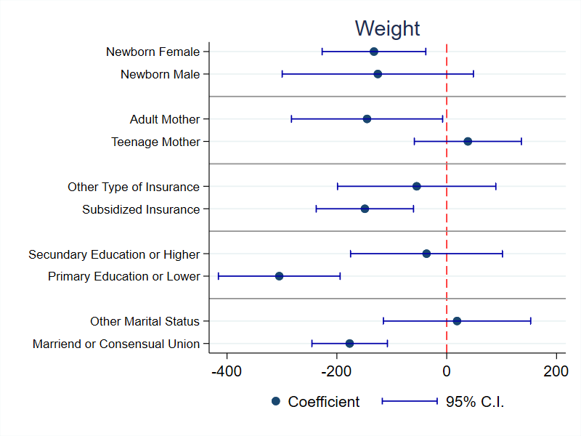
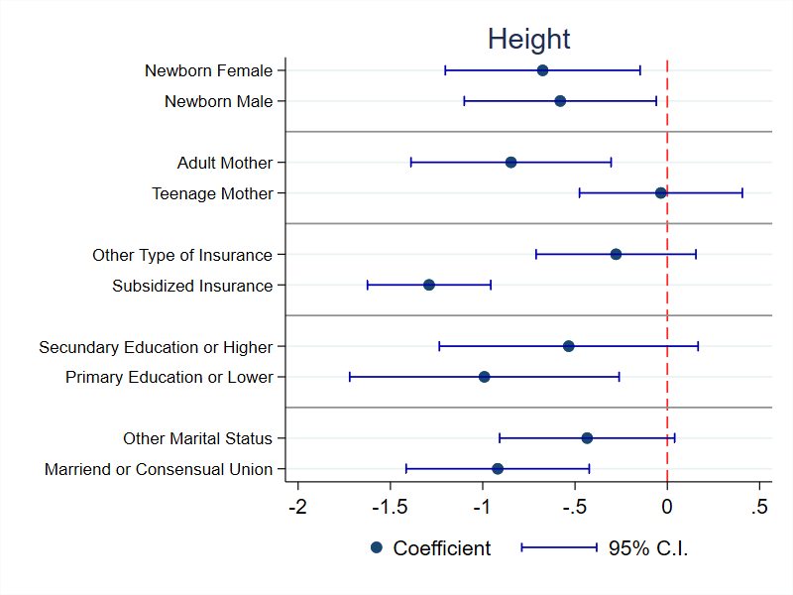
(c) Heterogeneous effects for Apgar ≥ 7
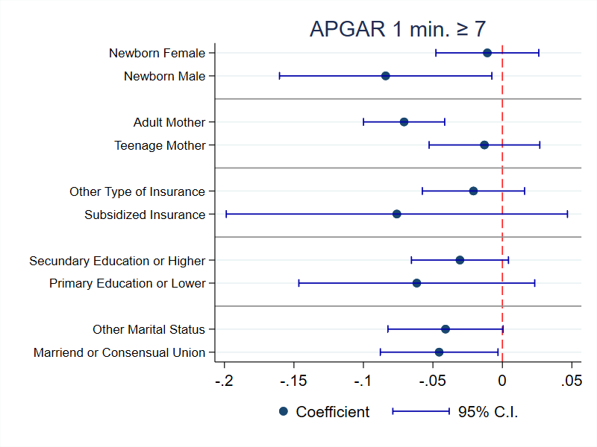

Notes: Figures 1a, 1b and 1c show estimated β coefficients from equation (1) based on Sant’Anna and Zhao (2020) DR estimation. Each estimated coefficient comes from a regression on the sub-sample specified on the vertical axis. See notes in Table 2 for further details.

we find no significant effect of the Orion Operation on this indicator.
On the contrary, the military operation may have exacerbated stress levels in pregnant women, which is detrimental to fetal health and development. Extensive research shows that maternal stress during pregnancy is associated with reduced fetal growth and lower birth weight Wadhwa et al. 1993, elevated stress hormone levels in the fetus Glynn et al. 2001, cognitive and behavioral issues, increased susceptibility to obesity and metabolic disorders, and impaired immune function in offspring (Entringer et al., 2012). Moreover, maternal stress during pregnancy is linked to higher risks of prematurity, low birth weight, and infant mortality (Davis et al., 2007).
Although the VSR data do not provide direct measurements of maternal stress, our findings in the previous section reveal that the effects on birth weight and height primarily manifest among married women or those in a consensual union, which can be attributed to the heightened stress experienced by women with partners during violent events that endanger their loved ones’ lives, as often observed in the context of the Colombian conflict (CNMH, 2023).
Further, anecdotal evidence and testimonies point to the significant psychological pres- sure inflicted on the residents of Comuna 13 during the Orion Operation (Aricapa 2017; Memoria Hist´orica 2011). The operation aimed to gain control of Comuna 13, an area pre- viously under the control of guerrilla groups. Unfortunately, the operation involved violence and intimidation toward residents. It began with a power outage that induced panic, fol- lowed by the destructive actions of two helicopters targeting many houses. This escalated into gunfire exchanges between official forces and militiamen, ultimately leading to the de- ployment of war tanks during the early morning hours. The inhabitants found themselves trapped between the advancing official forces and the presence of paramilitaries in the upper neighborhoods, resulting in a grim toll of 100 fatalities, 300 injuries, and around 500 missing persons (Memoria Hist´orica, 2011).
Finally, literature in development economics presents evidence that maternal stress is a primary mechanism through which conflict events impact maternal and fetal health (Spratlen et al., 2022). Hence, we can infer that increased stress levels are the primary plausible mechanism underlying the negative relationship between exposure to violence and birth weight.

Additional Tests
In this section, we aim to address potential concerns regarding identification issues. First, we examine the possibility of a composition effect among treated women. A critical concern is that Operation Orion may affect the number of newborns through intra-urban migration or fetal mortality, leading to a bias associated with changes in the composition of treated women. To test this hypothesis, we use a neighborhood-month panel, which sums all the birth registries in the VSR in each neighborhood by month. We present the results in Table 5, demonstrating that the number of births by neighborhood did not change because of the Orion operation. Thus, providing evidence that there was no change in the composition associated with the treatment units.

Table 4: Prematurity, healthcare, nutrition and the operation Orion

Dependent variable Gestational length Premature Prenatal Visits Small for Gestational Age
 | (1) | (2) |  | (3) | (4) |  | (5) | (6) |  | (7) | (8)
 | DiD | DR |  | DiD | DR |  | DiD | DR |  | DiD | DR
 | -0.04 | -0.16 |  | -0.05 | -0.02 |  | -0.11 | -0.22 |  | -0.0007 | -0.0008
Orion | (0.20) | (0.21) |  | (0.06) | (0.05) |  | (0.24) | (0.21) |  | (0.0018) | (0.0023)
Wild-bootstrap 95% C.I. | [-0.6, 0.4] | [-0.6, 0.2] |  | [-0.19, 0.16] | [-0.1, 0.1] |  | [-0.62, 0.43] | [-0.61, 0.17] |  | [-0.0049, 0.0034] | [-0.0055, 0.0038]
Observations | 10760 | 10760 |  | 10760 | 10760 |  | 9603 | 9603 |  | 10760 | 10760
Neighborhoods | 243 | 243 |  | 243 | 243 |  | 241 | 241 |  | 243 | 243
Mean DV | 36.65 | 36.65 |  | 0.38 | 0.38 |  | 5.41 | 5.41 |  | 0.01 | 0.01
SD DV | 1.59 | 1.59 |  | 0.48 | 0.48 |  | 2.43 | 2.43 |  | 0.09 | 0.09

Notes: This table presents the results from OLS regressions with birth weight and height as the dependent variables using data from 2002 and 2003. Orion is a dummy that takes the value of one for treated neighborhoods after exposure to the intervention. A baby born before 37 weeks of pregnancy is considered premature, and a baby is considered small for gestational age if her birthweight is below the 10th percentile for babies of the same gestational age. Columns (1), (3), (5), and (7) show the difference-in-difference (DiD) estimator using equation (1); columns (2), (4), (6), and (8) show the Sant’Anna and Zhao (2020) improved DR DiD estimator. All columns include the following controls: mother’s and father’s age, dummies for the type of insurance, dummies for the mother’s educational attainment, dummies for the mother’s marital status, number of previously born alive, number of pregnancies, and whether the newborn is female. Robust standard errors clustered by neighborhood are reported in parenthesis. Confidence intervals using wild cluster bootstrap with 10,000 replications are reported in brackets. Significance levels according to t-statistic: 1% ***, 5% **, 10% *.

Table 5: Number of newborns and the operation Orion

Dependent variable Number of Newborns

(1) (2)
DiD DR
-1.19 1.72
(0.97) (1.58)
Orion
Wild-bootstrap 95% C.I. | [-3.2, 1.1] | [-1.7, 5.1]
Observations | 3132 | 3132
Neighborhoods | 250 | 250
Mean DV | 11.39 | 11.39
SD DV | 15.49 | 15.49

Notes: This table presents the results from OLS regressions with the number of newborns per neighborhood as the dependent variables using data from 2002 to 2003. Orion is a dummy that takes the value of one for treated neighborhoods after exposure to the intervention. Column (1) estimates the DiD estimator using equation (1), and column (2) estimates the Sant’Anna and Zhao (2020) Improved DR DiD estimator. All columns include the following controls: mother’s and father’s age, dummies for the type of insurance, dummies for the mother’s educational attainment, dummies for the mother’s marital status, number of previously born alive, number of pregnancies, and whether the newborn is female. Robust standard errors clustered by neighborhood are reported in parentheses. 95% confidence intervals (C.I.) using wild cluster bootstrap with 10,000 replications reported in brackets. Significance levels according to t-statistic: 1% ***, 5% **, 10% *.

Table 6: Falsification test - Birth Outcomes and the operation Orion

Dependent variable Birth Weight Birth Height Apgar ≥ 7

(1) (2) (3) (4) (5) (6) DiD DR DiD DR DiD DR
Panel A. Average weeks

Orion
-11.08 | -11.00 -20.60 -0.02 0.04 -0.08
(27.32) | (25.41) (26.68) (0.31) (0.30) (0.30)

Wild bootstrap 95% C.I. | [-80.8, 53.2] | [-55.2, 33.2] | [-88.9, 45.7] | [-0.7, 0.8] | [-0.5, 0.6] | [-0.7, 0.7]
Observations | 13823 | 13823 | 13823 | 13823 | 13823 | 13823
Panel B. Minimum weeks
Orion
-20.57 | 6.87 -22.08 -0.02 0.20 -0.05
(37.47) | (35.40) (38.90) (0.25) (0.26) (0.25)

Wild bootstrap 95% C.I. | [-114.6, 80.2] | [-64.9, 78.6] | [-119.0, 88.6] | [-0.6, 0.6] | [-0.3, 0.7] | [-0.6, 0.6]
Observations | 13835 | 13835 | 13835 | 13835 | 13835 | 13835
Neighborhoods | 245 | 245 | 245 | 245 | 245 | 245
Mean DV | 3,087.15 | 3,087.15 | 3,087.15 | 49.10 | 49.10 | 49.10
SD DV | 504.04 | 504.04 | 504.04 | 2.73 | 2.73 | 2.73

Notes: This table presents the results from OLS regressions with birth weight, birth height, and Apgar score≥ 7 as the dependent variables using data from 2000 to 2001 and a fake intervention two years before the real one. See notes in Table 2 for further details. Robust standard errors clustered by neighborhood in parentheses. 95% confidence intervals (C.I.) using wild cluster bootstrap with 10000 replications reported in brackets. Significance levels according to t-statistic: 1% ***, 5% **, 10% *.

Second, we also conduct a falsification test that assumes the intervention occurred one year before the actual date. We assign “false treatment” to the newborns that appear in the VSR one year before the Orion Operation. Then, using the birth registries from 2001 to 2002 instead of 2002 and 2003, we run equation (1) in the same conditions used for the primary sample. Here we test whether this placebo treatment group for the Orion operation significantly impacts birth weight. If it does, then the impact must come from some underlying differences in trends between treated and control neighborhoods rather than from Orion. The results are shown in Table 6. We find that the placebo Orion operation has no significant effect on birth weight, height, or the probability of having an Apgar greater than 7, suggesting that underlying differences in trends between treated and control neighborhoods do not drive our results.

Figure 2: Permutation test: Randomizing treated neighborhoods
    - Birth weight (b) Birth height
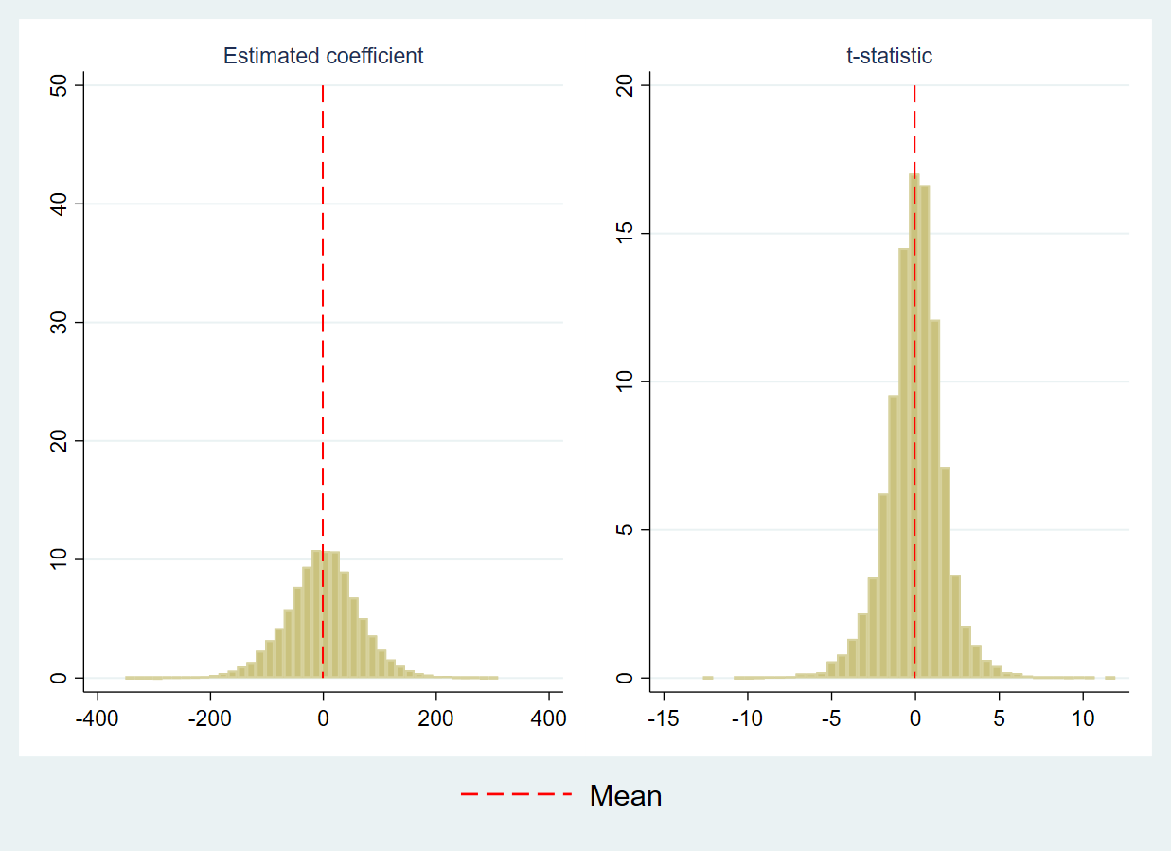
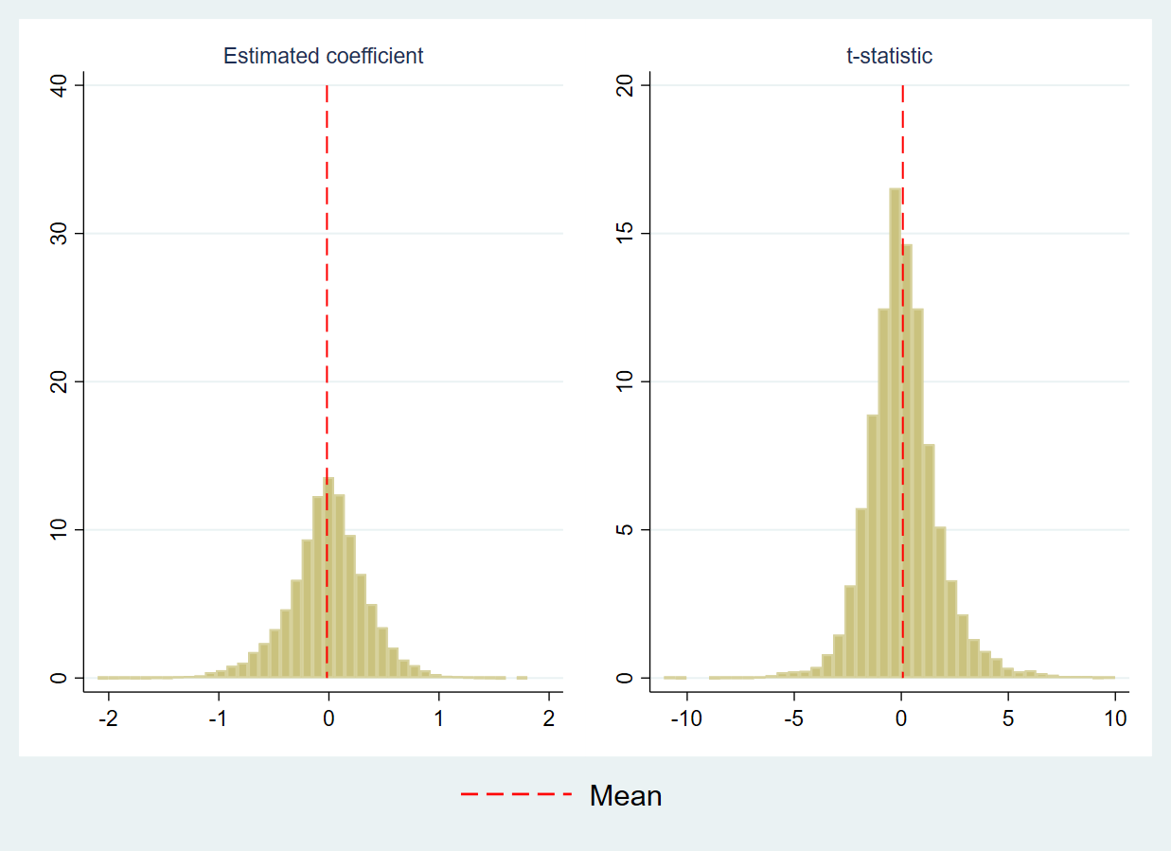
(c) APGAR ≥ 7
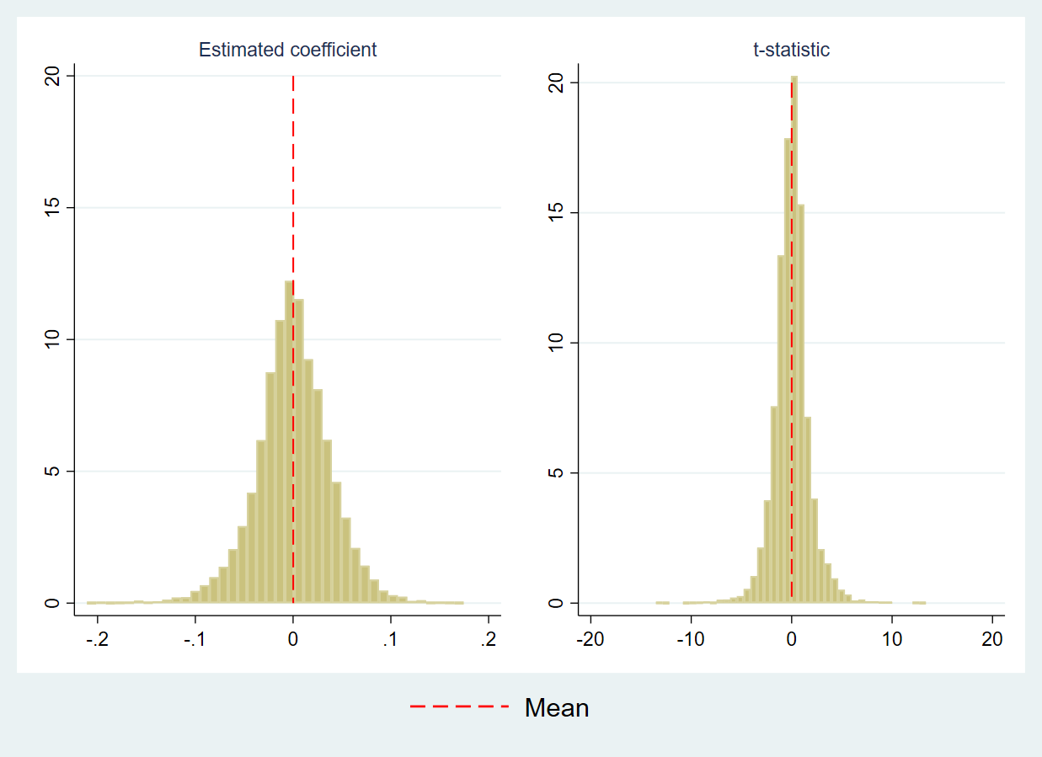

Finally, a permutation test was carried out by randomly assigning the treatment to different neighborhoods 10,000 times and then re-estimating using the DiD specification of equation (1) on birth outcomes for each random assignment. The distribution for both the coefficient and t-statistic is displayed in Figure 2. The results suggest that about 80 percent of the time, exposure to Operation Orion has no significant effect on birth outcomes. On average, the evidence is insufficient to reject the null hypothesis that random exposure to the state military operation does not affect birth outcomes.

Conclusion
In this paper, we have examined the effects of the state’s efforts to end the armed conflict with guerrillas in Comuna 13 in 2002 on newborns’ birth weight. Our findings reveal that exposure to the Orion operation led to a significant reduction in birth weights in the inter- vened neighborhoods compared to other areas. Specifically, neighborhoods that experienced the Orion operation exhibited an average birth weight reduction of 4.1% and a birth height reduction of 1.36% compared to non-intervened areas. Additionally, there was a 4.3% de- crease in the probability of infants being born with an Apgar score greater than 7. This suggests that the increased stress levels among pregnant women exposed to the operation likely contributed to the birth weight and vitality decline.
One potential concern regarding our results is the possibility of migration biasing our estimated coefficients due to pregnant women moving to non-treated neighborhoods. How- ever, we address this issue by showing that the number of births in each area remained unchanged following the Orion operation, providing evidence that migration did not affect our estimates.
In the case of the Orion operation, our findings underscore the importance of examining the unintended consequences of violent military interventions in urban areas. Our study highlights the substantial costs of the operation on children’s health, revealing that the opportunity cost of such military interventions is more extensive than expected. Future state interventions should consider that exposure to violence resulting from confrontations with illegal armed groups has detrimental effects on birth weight and vitality. Thus, alternative intervention strategies that are less violent or non-military should be explored to mitigate these unintended consequences.
Recognizing that being born with below-average weight and height has short-term conse- quences and long-term effects is crucial, as documented in the literature. These consequences are associated with other health issues and academic performance, ultimately impacting up- ward social mobility.
As a final reflection, it is important to emphasize the often-overlooked plight of pregnant mothers who endure moments of stress during times of war in a country. The focus is typically on immediately measurable damages such as casualties and material destruction. However, it is crucial to acknowledge the hidden, long-term consequences that affect the human capital of war-torn nations. In other words, some less visible victims bear severe consequences of living in a war, and this article sheds light on the significance of pregnant mothers and unborn babies as part of these affected populations.

References
Abu-Saad, K. and Fraser, D. (2010). Maternal nutrition and birth outcomes. Epidemiologic reviews, 32(1):5–25.
Akresh, R., Lucchetti, L., and Thirumurthy, H. (2012). Wars and child health: Evidence from the eritrean-ethiopian conflict. Journal of Development Economics, 99(2):330–340.

Akresh, R., Verwimp, P., and Bundervoet, T. (2011). Civil war, crop failure, and child stunting in rwanda. Economic Development and Cultural Change, 59(4):777–810.
Alexander, G. R. and Korenbrot, C. C. (1995). The role of prenatal care in preventing low birth weight. The future of children, pages 103–120.
Almond, D., Chay, K. Y., and Lee, D. S. (2005). The costs of low birth weight. The Quarterly Journal of Economics, 120(3):1031–1083.
Almond, D., Doyle Jr, J. J., Kowalski, A. E., and Williams, H. (2010). Estimating marginal returns to medical care: Evidence from at-risk newborns. The quarterly journal of eco- nomics, 125(2):591–634.
Angrist, J. D. and Kugler, A. D. (2008). Rural windfall or a new resource curse? coca, income, and civil conflict in colombia. The Review of Economics and Statistics, 90(2):191–215.
Arias, C. (2021). Qu´e esperar cuando est´as esperando y la guerra termin´o. Phd thesis, Universidad de los Andes, Bogot´a, D.C. Available at https://repositorio.uniandes
.edu.co/handle/1992/62603.
Aricapa, R. (2017). Comuna 13. Cr´onica de una guerra urbana: De Ori´on a la Escombrera.
B de Books.
Armijos Bravo, G. and Vall Castell´o, J. (2021). Terrorist attacks, Islamophobia and new- borns’ health. Journal of Health Economics, 79(July):102510.
Brown, R. (2018). The mexican drug war and early-life health: The impact of violent crime on birth outcomes. Demography, 55(1):319–340.
Brown, R. (2020). The Intergenerational Impact of Terror: Did the 9/11 Tragedy Impact the Initial Human Capital of the Next Generation? Demography, 57(4):1459–1481.
Bundervoet, T., Verwimp, P., and Akresh, R. (2009). Health and civil war in rural burundi.
Journal of Human Resources, 44(2):536–563.
Camacho, A. (2008). Stress and birth weight: evidence from terrorist attacks. American Economic Review, Papers & Proceedings, 98(2):511–15.
Camacho, A. and Rodriguez, C. (2013). Firm exit and armed conflict in colombia. Journal of Conflict Resolution, 57(1):89–116.
CNMH (2023). El conflicto armado en cifras. https://micrositios
.centrodememoriahistorica.gov.co/observatorio/portal-de-datos/el-conflicto
-en-cifras/. Centro Nacional de Memoria Historica. Accessed: 2023-03-24.
Conzo, P. and Salustri, F. (2019). A war is forever: The long-run effects of early exposure to World War II on trust. European Economic Review, 120:103313.

Currie, J. (2011). Inequality at birth: Some causes and consequences. American Economic Review, 101(3):1–22.
Dagnelie, O., De Luca, G. D., and Maystadt, J.-F. (2018). Violence, selection and infant mortality in congo. Journal of health economics, 59:153–177.
Davis, E. P., Glynn, L. M., Schetter, C. D., Hobel, C., Chicz-Demet, A., and Sandman, C. A. (2007). Prenatal exposure to maternal depression and cortisol influences infant tempera- ment. Journal of the American Academy of Child & Adolescent Psychiatry, 46(6):737–746.
de Oliveira, V. H., Lee, I., and Quintana-Domeque, C. (2021). Natural disasters and early human development: Hurricane catarina and infant health in brazil. Journal of Human Resources, pages 0816–8144R1.
Dube, O. and Vargas, J. F. (2013). Commodity price shocks and civil conflict: Evidence from colombia. The review of economic studies, 80(4):1384–1421.
Duque, V. (2017). Early-life conditions and child development: Evidence from a violent conflict. SSM-population health, 3:121–131.
Entringer, S., Buss, C., Swanson, J. M., Cooper, D. M., Wing, D. A., Waffarn, F., and Wad- hwa, P. D. (2012). Fetal programming of body composition, obesity, and metabolic func- tion: the role of intrauterine stress and stress biology. Journal of nutrition and metabolism, 2012.
Firpo, S., Fortin, N. M., and Lemieux, T. (2009). Unconditional quantile regressions. Econo- metrica, 77(3):953–973.
Freer, J., Orr, J., Morris, J. K., Walton, R., Dunkel, L., Storr, H. L., and Prendergast, A. J. (2022). Short stature and language development in the united kingdom: a longitudinal analysis of children from the millennium cohort study. BMC medicine, 20(1):1–13.
Glynn, L. M., Wadhwa, P. D., Dunkel-Schetter, C., Chicz-DeMet, A., and Sandman, C. A. (2001). When stress happens matters: effects of earthquake timing on stress responsivity in pregnancy. American journal of obstetrics and gynecology, 184(4):637–642.
Gonzalez, R. M. and Gilleskie, D. (2017). Infant mortality rate as a measure of a country’s health: a robust method to improve reliability and comparability. Demography, 54(2):701– 720.
Grossman, D., Khalil, U., and Ray, A. (2019). Terrorism and early childhood health outcomes: Evidence from Pakistan. Social Science and Medicine, 237(September 2018):112453.
Hameed, M. A., Rahman, M. M., and Khanam, R. (2023). The health consequences of civil wars: evidence from Afghanistan. BMC Public Health, 23(1):1–13.

Kc, A., Wrammert, J., Clark, R. B., Ewald, U., Vitrakoti, R., Chaudhary, P., Pun, A., Raaijmakers, H., and M˚alqvist, M. (2016). Reducing perinatal mortality in nepal using helping babies breathe. Pediatrics, 137(6).
Koppensteiner, M. F. and Manacorda, M. (2016). Violence and birth outcomes: Evidence from homicides in brazil. Journal of Development Economics, 119:16–33.
Kramer, M. S. (1987). Determinants of low birth weight: methodological assessment and meta-analysis. Bulletin of the world health organization, 65(5):663.
Kreif, N., Mirelman, A., Suhrcke, M., Buitrago, G., and Moreno-Serra, R. (2022). The impact of civil conflict on child health: Evidence from colombia. Economics & Human Biology, 44:101074.
Le, K. and Nguyen, M. (2020). Armed conflict and birth weight. Economics & Human Biology, 39:100921.
Lin, W. (2009). Why has the health inequality among infants in the us declined? accounting for the shrinking gap. Health Economics, 18(7):823–841.
MacKinnon, J. G. and Webb, M. D. (2019). Wild bootstrap randomization inference for few treated clusters. In The Econometrics of Complex Survey Data, volume 39, pages 61–85. Emerald Publishing Limited.
MacKinnon, J. G. and Webb, M. D. (2020). Randomization inference for difference-in- differences with few treated clusters. Journal of Econometrics, 218(2):435–450.
Mansour, H. and Rees, D. I. (2012). Armed conflict and birth weight: Evidence from the al-aqsa intifada. Journal of Development Economics, 99(1):190–199.
Memoria Hist´orica (2011). La huella invisible de la guerra: Desplazamiento forzado en la Comuna 13. Editorial Taurus, Bogot´a, Colombia.
Montoya, P. (2021). La Sombra de Ori´on. Penguin Random House.
Moore, E. A., Harris, F., Laurens, K. R., Green, M. J., Brinkman, S., Lenroot, R. K., and Carr, V. J. (2014). Birth outcomes and academic achievement in childhood: A population record linkage study. Journal of Early Childhood Research, 12(3):234–250.
Poveda, A. C. and Mart´ınez, C. I. P. (2023). Violence and economic development in Mexico: a panel data cointegration approach. Development Studies Research, 10(1).
Quintana-Domeque, C. and R´odenas-Serrano, P. (2017). The hidden costs of terrorism: The effects on health at birth. Journal of Health Economics, 56:47–60.

Raghavan, S., Huang, J., Tcheandjieu, C., Huffman, J. E., Litkowski, E., Liu, C., Ho, Y.-
L. A., Hunter-Zinck, H., Zhao, H., Marouli, E., et al. (2022). A multi-population phenome- wide association study of genetically-predicted height in the million veteran program. PLoS Genetics, 18(6):e1010193.
Rodr´ıguez, L. (2022). Violence and newborn health: Estimates for colombia. Health eco- nomics, 31(1):112–136.
Roodman, D., Nielsen, M. Ø., MacKinnon, J. G., and Webb, M. D. (2019). Fast and wild: Bootstrap inference in stata using boottest. The Stata Journal, 19(1):4–60.
Sant’Anna, P. H. and Zhao, J. (2020). Doubly robust difference-in-differences estimators.
Journal of Econometrics, 219(1):101–122.
Sherrieb, K. and Norris, F. H. (2013). Public health consequences of terrorism on maternal– child health in new york city and madrid. Journal of Urban Health, 90:369–387.
Slyker, J. A., Patterson, J., Ambler, G., Richardson, B. A., Maleche-Obimbo, E., Bosire, R., Mbori-Ngacha, D., Farquhar, C., and John-Stewart, G. (2014). Correlates and outcomes of preterm birth, low birth weight, and small for gestational age in hiv-exposed uninfected infants. BMC pregnancy and childbirth, 14(1):1–10.
Spratlen, M. J., Perera, F. P., Sjodin, A., Wang, Y., Herbstman, J. B., and Trasande,
L. (2022). Understanding the Role of Persistent Organic Pollutants and Stress in the Association between Proximity to the World Trade Center Disaster and Birth Outcomes. International Journal of Environmental Research and Public Health, 19(4).
Torche, F. (2011). The effect of maternal stress on birth outcomes: exploiting a natural experiment. Demography, 48(4):1473–1491.
Torche, F. and Shwed, U. (2015). The hidden costs of war: Exposure to armed conflict and birth outcomes. Sociological Science, 2:558–581.
Vargas, J. F. (2012). The persistent colombian conflict: subnational analysis of the duration of violence. Defence and Peace Economics, 23(2):203–223.
Villar, J., Ismail, L. C., Victora, C. G., Ohuma, E. O., Bertino, E., Altman, D. G., Lambert, A., Papageorghiou, A. T., Carvalho, M., Jaffer, Y. A., et al. (2014). International stan- dards for newborn weight, length, and head circumference by gestational age and sex: the newborn cross-sectional study of the intergrowth-21st project. The Lancet, 384(9946):857– 868.
Wadhwa, P. D., Sandman, C. A., Porto, M., Dunkel-Schetter, C., and Garite, T. J. (1993). The association between prenatal stress and infant birth weight and gestational age at birth: a prospective investigation. American journal of obstetrics and gynecology, 169(4):858–865.

World Health Organization (2016). Pregnant women must be able to access the right care at the right time.

Appendices

Figure A1: Medellin, Comuna 13, and the operation Orion
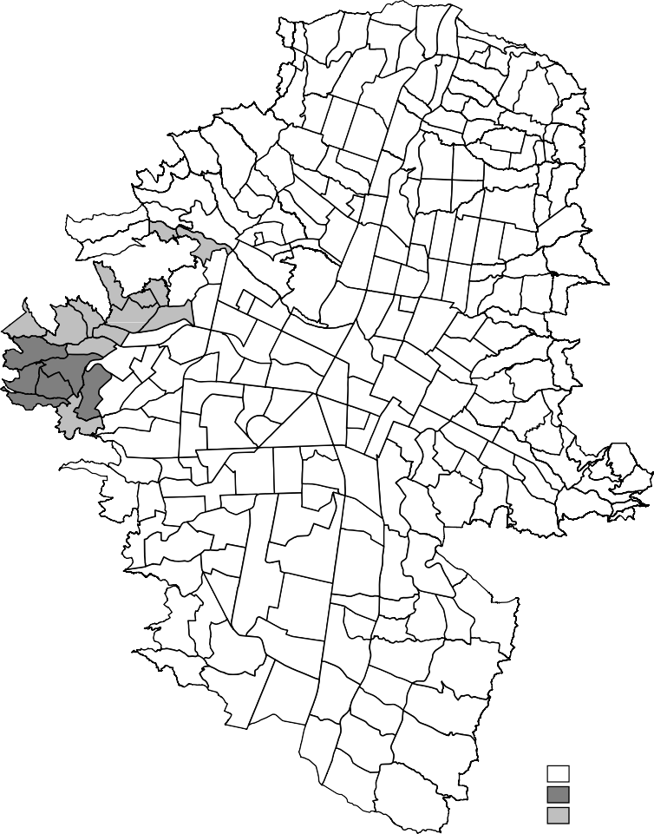
Medellín Orión
Comuna 13

Figure A2: Unconditional Quantile Regression for Birth Weight
0
0
100

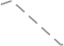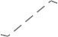15 20 25 30 35 40 45 50 55 60 65 70 75 80 85
-300
-200
-100
Percentile

Coefficient 95% C.I.
Percentile values: 25 - 2800, 50 - 3100, 75 - 3396

Figure A3: Unconditional Quantile Regression for Birth Height
.5
1

0 25 50 75 100
-1.5
-1
-.5
Percentile
Coefficient 95% C.I.
25, 50, and 75 percentiles correspond to 48 cms, 49 cms, and 51 cms, respectively

Table A1: Birth outcomes and the operation Orion - Third trimester

Dependent variable Birth Weight Birth Height Apgar 1 min ≥ 7

(1) (2) (4) (5) (7) (8) DiD DR DiD DR DiD DR
-9.99 -15.01 0.07 0.12 0.02 0.02
(85.03) (71.57) (0.35) (0.25) (0.02) (0.03)
Orion
Wild-bootstrap 95% C.I. | [-242.6, 271.1] | [-158.9, 128.9] | [-0.68, 1.19] | [-0.42, 0.66] | [-0.06, 0.07] | [-0.04, 0.08]
Observations | 11497 | 11497 | 11497 | 11497 | 11497 | 11497
Neighborhoods | 243 | 243 | 243 | 243 | 243 | 243
Mean DV | 3,071.89 | 3,071.89 | 48.91 | 48.91 | 0.93 | 0.93
SD DV | 499.27 | 499.27 | 2.70 | 2.70 | 0.26 | 0.26

Notes: This table presents the results from OLS regressions with birth weight, height, and Apgar 1 minute greater or equal to seven as the dependent variables using data from 2001 to 2002 for newborns exposed during the third trimester of pregnancy. Orion is a dummy that takes the value of one for treated neighborhoods after exposure to the intervention. Columns (1), (3), and (5) estimate the DiD estimator using equation (1), and columns (2), (4), and (6) estimate theSant’Anna and Zhao (2020) Improved DR DiD estimator. All columns include the following controls: mother’s and father’s age, dummies for the type of insurance, dummies for the mother’s educational attainment, dummies for the mother’s marital status, number of previously born alive, number of pregnancies, and whether the newborn if female. Robust standard errors clustered by neighborhood are reported in parentheses. 95% confidence intervals (C.I.) using wild cluster bootstrap with 10,000 replications reported in brackets. Significance levels according to t-statistic: 1% ***, 5% **, 10% *.

Table A2: Birth outcomes and the operation Orion - TWFE estimates

Dependent variable Birth Weight Birth Height APGAR 1 min ≥ 7

(1) (2) (3)
-78.74*** -0.62*** -0.04***
(28.11) (0.22) (0.01)
Orion
Wild-bootstrap 95% C.I. | [-168.7, -23.9] | [-1.23, 0.06] | [-0.08, -0.01]
Observations | 10760 | 10760 | 10760
Neighborhoods | 243 | 243 | 243
Mean DV | 3,066.50 | 49.08 | 0.92
SD DV | 459.36 | 2.41 | 0.27

Notes: This table presents the results from OLS regressions with birth weight, height, and Apgar 1 minute greater or equal than seven as the dependent variables using data from 2002 to 2003. Orion is a dummy that takes the value of one for treated neighborhoods after exposure to the intervention. All columns show the two-way fixed effects estimates using the following specification Y_{int} = α + η_{n} + δ_{t} + β · Orion_{n} × P ost_{t} + θX_{it} + ε_{int}. All columns include the following controls: mother’s and father’s age, dummies for the type of insurance, dummies for mother’s and father’s educational attainment, dummies for mother’s marital status, number of previously born alive, number of pregnancies, and whether the newborn if female. Robust standard errors clustered by neighborhood are reported in parentheses. 95% confidence intervals (C.I.) using wild cluster bootstrap with 10,000 replications reported in brackets. Significance levels according to t-statistic: 1% ***, 5% **, 10% *.



